

McKenzie Elementary School

2024-2025

Parent & Family

Engagement Policy for

Shared Student Success

*Policy Created September 16, 2022*

*Policy updated September 10, 2024*

# McKenzie Elementary School

Tonya Brown, Principal

Zach Renfro, Assistant Principal

**-----------------------------------------------**

**School Plan for Shared Responsibility**

**for Student Achievement**

IN THIS ISSUE

|  |  |
| --- | --- |
| **What is it?**  **This is a plan that describes how McKenzie Elementary will provide opportunities to improve family engagement to support student learning. McKenzie Elementary values the contributions and involvement of families to establish an equal partnership to focus on improving student achievement. This plan describes the different ways that McKenzie Elementary will support family engagement and how families can help plan and participate in activities and events to promote student learning at school and at home.** | **What is Title I?**  **McKenzie Elementary is identified as a Title I school. Title I is designed to support State and local school reform efforts tied to the challenging State academic standards to improve teaching and learning for students. Title I programs must be based on effective means of improving student achievement and include strategies to support family engagement. All Title I schools must jointly develop with parents and family members a written parent and family engagement policy.** |

|  |  |
| --- | --- |
|  |  |

**How is it revised?** 

The MES Parent and Family Engagement Policy for Shared Student Success will be

revised on a designated time as needed. McKenzie Elementary School

will invite all families to have input via surveys regarding this plan. Additionally, family input and comments regarding this plan are welcome during the school year through an online form located on our MES school website. All feedback received during the year will be used to revise the plan for the next school year. We will also continue to distribute an annual survey online to ask parents for their suggestions on the plan and the use of funds for family engagement. Families can also give feedback during meetings and activities during the school year.

**Who is it for? Where is it available?**

**At the beginning of the year, the plan will be included in the student handbook and given to all students. The plan will also be posted on the school website and social media. Families can also retrieve a copy of the plan in the front office of the school upon request.**

**All students participating in the Title I,**

**Part A program, and their families are**

**encouraged and invited to fully participate**

**in the opportunities described in this plan.**

**McKenzie Elementary will provide full**

**opportunity for the participation of parents**

**and family members with limited English,**

**with disabilities, and of migratory children.**

# 2024-2025 Distict Goals

When the plan is implemented it will be the shared responsibility and collaborative effort of the school, parents, and community to work together to achieve an exemplary achievement level as measured by the TN Ready Assessment.

|  |
| --- |
|  |

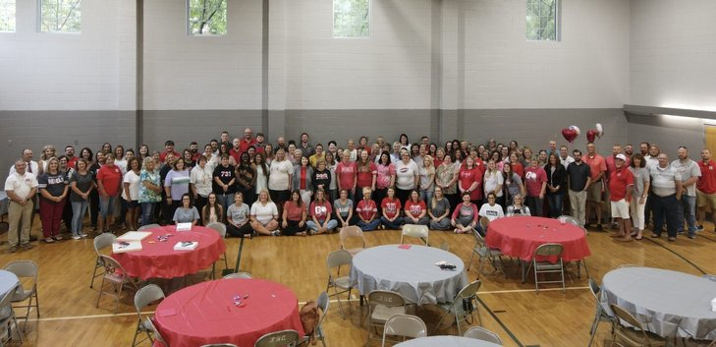

# Rebels Open Season with Wins at TN River Classic | The Mckenzie Banner

**When students, schools, families, and**

**communities come together….we CAN achieve our goals**



# 

# Parent and Family Engagement

# Elementary School Goals:

M.E.S. administrators and teachers will study our student achievement data to determine the most important areas to determine the most important areas for improvement in our school. M.E.S. believes that family engagement means the participation of parents and family members in a regular two-way, and meaningful communication involving student academic learning and other school activities, including ensuring:

-That parents play an integral role in assisting their child’s learning.

-Thant parents are encouraged to be actively involved in their child’s education at school.

-That parents are full partners in their child’s education and are included, as appropriate, in decision-making and on advisory committees to assist in the education of their child.

# School-Parent Compacts

As part of this plan, McKenzie Elementary and our families will develop a school-parent compact. A compact is a written agreement that families, teachers, and students jointly develop to explain how everyone will work together to ensure all students reach grade- level standards. The compacts will be reviewed and updated annually based on feedback from families, students, and teachers during various activities and meetings. The school- parent compacts will be displayed in the M.E.S. front office and posted on our school website. The compacts are shared with parents during parent-teacher conferences, are posted on our school website and extra copies are always available in the front office upon request.

McKenzie Elementary School is Branching Out!

McKenzie Elementary will take the following measures to empower and support parents and family members as an important foundation of our school in order to strengthen the school and reach our goals. Beginning this year, all parent forms will be completed online. We are going paperless. If you need assistance, we will be glad to help.

We Will:

* Ensure that all information related to school and family programs, meetings, and other activities published in both English and Spanish; posted on the school website; and included in the monthly school newsletter for all families.
* Provide monthly trainings for staff during their planning periods on strategies to improve communication with families and ideas to increase family engagement in reading and math for our students outside of the classroom. Staff will also share promising practices during regularly scheduled faculty meetings.
* Partner with early childhood programs, middle and high schools, college and career ready resources or organizations, parent resource centers, or other programs (as applicable) to help prepare parents and their children for successful school transitioning.
* Share information in English and Spanish on the school website and in the school newsletter for families to understand the school’s academic standards and assessments as well as the ways families can monitor their child’s progress and work with educators.
* Communicate with all families and the community on a regular basis regarding school-wide events and activities through phone messages, school website, social media, NOTIFYMe, the Remind App and the Class Dojo App.
* Work with our families to develop relevant trainings and helpful presentations to educate our staff on the importance of parent and family engagement and how to support student learning.
* Provide necessary materials and handouts for parents at conferences, meetings, and activities to help parents work with their child to improve their child’s achievement.
* Use our Partners in Education and School-Community Team to improve awareness of the activities and events listed in the school parent and family engagement policy.
* Collect feedback from parents and family members at all events, place input cards around the building with a designated drop off box and post a suggestion form on the school website in order to respond to parents’ requests for additional support for parent and family engagement activities.

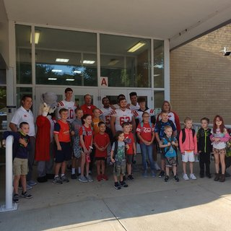

Let’s Get Together!

McKenzie Elementary will host the following events to build the capacity for strong family engagement and support a partnership among the school, families, and the community to improve student academic achievement. Most meetings for parents and family members will be held in the evening at 6:00 pm one day during the week.

See the entire listing of events on our website[:](http://www.poplarschool.org/) <https://mckenzieelemtn.schoolinsites.com/>

## Annual Title I Meeting –

We invite you to an evening of learning and sharing about our Title I program, including our parent and family engagement policy, the school-wide plan, and the school- parent compact. Invitations will be emailed and posted in the school newsletter and on social media.

**Open House –**

Meet your child’s teacher and learn about important grade level skills and standards that your child will be working on this year.

**Parent-Teacher and Student Conferences –** Oct. 24 (12:30-6:30) and Mar. 20 (12:30-6:30)

**Parent and Family Engagement Standards**

McKenzie Elementary and our families have adopted the National PTA

Standards for Family -

School Partnerships as the school’s model in

engaging parents, students, and the community. These standards are:

1

. Welcoming All Families

2

. Communicating Effectively

3

. Supporting Student Success

4

. Speaking Up for Every Child

5

. Sharing Power

6

. Collaborating with Community

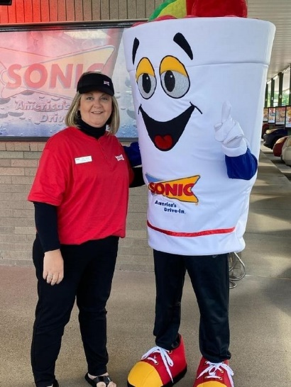

School Community Team

McKenzie Elementary invites all families to join the School Community Team to share ideas and ways to involve others to build partnerships with school, families, and the community. The team will meet four times during the school year, but parents and family members can also submit their ideas or suggestions at any school activity, school meeting, as well as through our family surveys and website. If you would like to learn more about the School Community Team, please contact Tonya Brown at 731-352-5272 or complete the interest form below and leave it in the front office.

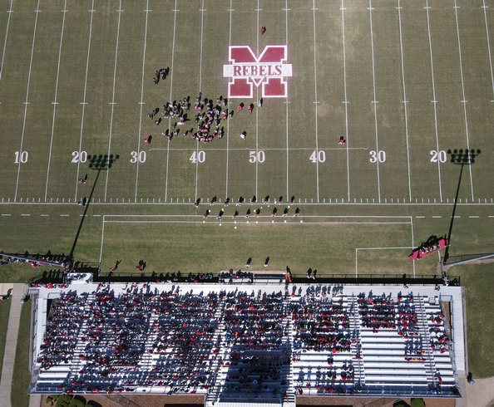

|  |
| --- |
| **School Community Team**  Yes, I am interested and wish to join the School Community Team  Please contact me so I can learn more about joining the School Community Team  Please send me notifications about future meetings and updates.    **Name:**    **Child’s Name and Grade Level:**    **Address:**    **Phone Number:**    **Email Address:** |

# Share Your Thoughts

We want to hear from you! If you have any suggestions or if there is any part of this policy that you feel is not satisfactory with the students’ and the school’s goals for academic achievement, please provide us with your comments in the space provided and leave this form in the front office:

**Name (optional): Phone Number (optional):**

**Comments:**