Making an alphabet book

We will do a quick review of the Habits for Leader in Me.

This week we will focus on comparing word lengths, initial sound consonants, letter recognition and letter sounds of n-z, and syllables.

MATH:

We will finish topic 1 in math. This week we will focus on basic subtraction. We will take a topic test on Friday

Week of August 22

Homework-

You will find a math sheet in your child’s binder. This sheet will be there homework for the week and also a great way to review for the test on Friday. The sheet is due on Friday and they will receive a treat for turning it in.

High Freq. Words:

Have I a there

Contact Information

Email: Pamela.luker@acboe.net

Website: prattvilleprimary.com/pamelaluker

LANG. ARTS:

SS/SCIENCE:

READING:

Our Learning





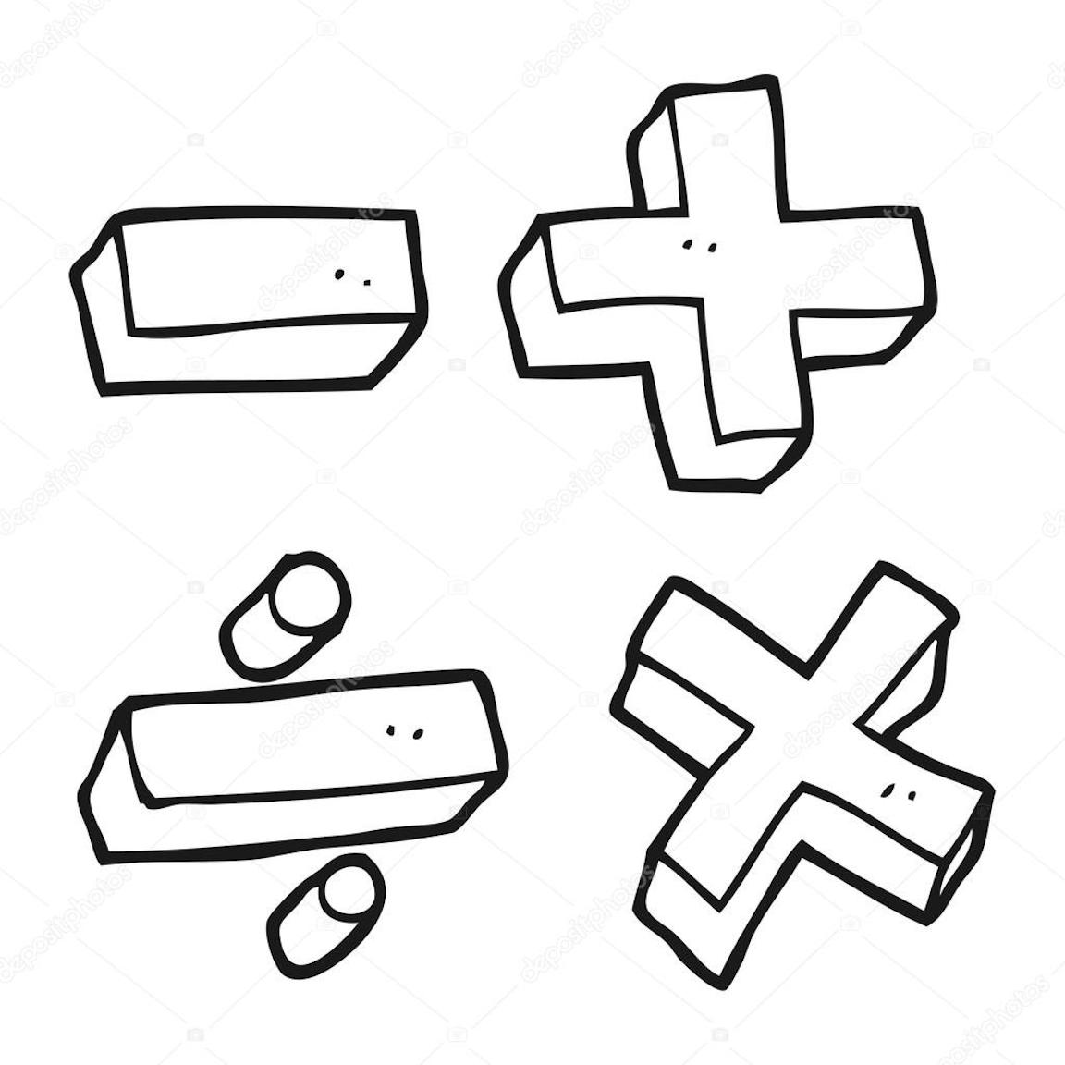



Upcoming Events

August 26- spirit day- wear sunglasses

August 26- special snack $1 slushies

August 30- Curriculum night 5:30-6:30

Reminders

\* if you have put money is your child’s binder please tell them to turn it in to me- especially if they need to buy snack; that is sold first thing in the morning

Mrs. Luker’s Class