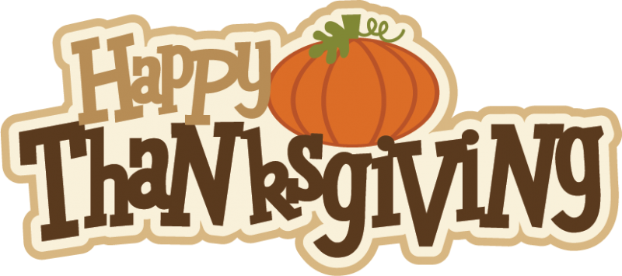

**Reading News**

Mrs. Williams

Date: November 18, 2024

**Reading:** The Mohawk People

**Word Study:** spell words with -le

**Vocabulary**

**convince –** to persuade someone to do something or believe something that is true

**replace -** provide or find a substitute for something else

**explore -** to travel in or through an unknown area to learn more about it

**destruction -** the act of causing so much damage to something that is not longer exists

**opportunity -** an event or chance that makes it possible to do something