Mrs. Daniels Second Grade Class Weekly Newsletter

Mrs. Daniels Second Grade Class Newsletter  August 21-25, 2023  Leader in Me!  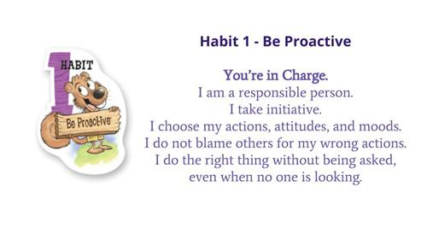 | What we will be learning this week.  Reading- See Skill Sheet in folder  Math-Fluently add and `Subtract numbers to 20  Monday- 1.6 I can use addition to help me subtract quickly and accurately  Tuesday-1.7 I can make a 10 to help me subtract quickly and accurately.  daily grade 1 test  Wednesday- 1.8 I can add and subtract quickly using mental math  Thursday-1.9 I can use addition and subtraction to solve word problems  Science: continuing with solid, liquids, and gas  Social Studies: Connecting communities’ week 1
Things to Remember  Spirit Day- August 25(more information to come)  Curriculum Night: August 29 @ 5:30  Labor Day: September 4, 2023  Special Snack-Spirit Snack -Slushy  Check your child’s folder nightly for important papers or practice reading and math sheets.  I encourage you to go over about 5 to 10 second grade words nightly. | Important Information  Star reading Test: August 21, 2023  Math 1st minor grade test will be on August 22, 2023  Star Math Test- August 23, 2023  Reading Study Sheet: Study sheet is also in folder.  On Tuesday, August 22th, we will take major grade tests on reading and spelling words. Please use the vocabulary words and spelling words in your child’s folder.
s

