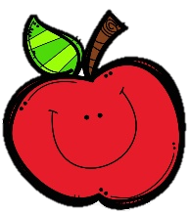
Mrs. Burns’ Messages
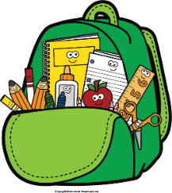
October 17-21, 2022

Reading Assessments
Thursday Quizzes: Phonics, Main Idea, Kinds of Sentences and End Marks, Vocabulary
Friday Assessments: Reading Skills Test, Grammar Test, Spelling Test
Mon. – crazy hair, Tue. – western, Wed. – red,
Thu. – neon/bright, Fri - costume
Friday, October 28: Fall Fun Day
Wednesday, November 9: Progress Reports
Reading Story and Skills:  Story: A River of Ice  Phonics/Fluency:  long vowels:  /o/ spelled o and o_e  /u/ spelled u and u_e;  inflectional endings  –er, -est  Text-Based Comprehension:  Main Idea and  Details  Grammar/Language:  Kinds of Sentences  and End Marks |  | Vocabulary Words  - glacier– a large mass of ice in very cold regions or on the  tops of high mountains, formed by snow that does not melt  - over – during the time of; throughout  - time – the period during which all events, conditions, and  actions happen or continue  - press – to bear down on  - crevasse– a deep crack or crevice, especially in a glacier  - happens – takes place; occurs  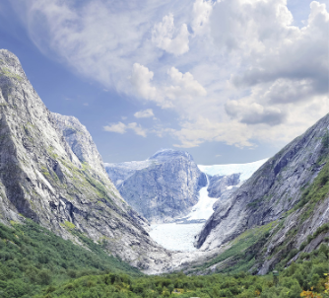  - scratch – to cut or mark with something rough, sharp, or  pointy  - rub – to move against something  else or against each other  - valley – an area of low land  between hills or mountains  - fjords – a long, narrow inlet  of the sea between high cliffs
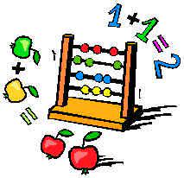  Math  Topic 4: Fluently Add Within 100  Lesson 5: Break Apart Numbers and  Add Using Mental Math  Lesson 6: Add More than Two 2-Digit Numbers  Lesson 7: Practice Adding Using Strategies  Lesson 8: Solve One-Step and Two-Step Problems |  |  |  | Social Studies/Science  This week we will identify national historical figures and celebrations that exemplify fundamental democratic values, including equality, justice, and responsibility for the common good.
Spelling Words:
- menu  - nose | - most  - cube |  | - joke  - unit | - vote  - fuse | - over  - mule
Monday, October 17: Report Cards Issued
Tuesday, October 18: Fundraiser Kick-Off
Friday, October 21: Honor Roll Treat
October 24-28: Red Ribbon Week

