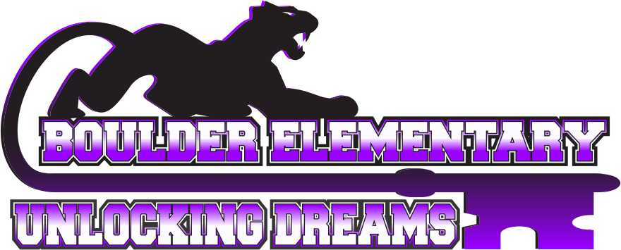
Vision Statement: Committed to pursuing a community of excellence.

Mission: Here at Boulder Elementary School, we are committed to pursuing a community of excellence by engaging students in a positive environment that supports all they do.

AGENDA
BOULDER ELEMENTARY BOARD OF TRUSTEES MEETING
5:30 P.M., MONDAY OCTOBER 12, 2026
BOULDER ELEMENTARY LIBRARY ROOM #100
- Call to Order-Chairperson
  - Pledge of Allegiance
- Agenda Review
  - Consent Agenda
    - Approval Claims – October 2026
    - Approval previous month minutes
    - Approval Student Activities Ledger
    - Budget vs. Actual
- Elementary Announcements and Public Comment on Elementary Issues.
THE BOARD WELCOMES AND ENCOURAGES PUBLIC COMMENT. ANYONE WISHING TO ADDRESS THE BOARD IS ENCOURAGED TO DO SO WITH THESE STIPULATIONS:
The Board may limit the amount of time for comment if they become extensive. If the speaker begins to infringe on the right to privacy of another, the Board may interrupt and end the comments on that issue. Even if the comments are entirely appropriate, the Board will take no action on them at this meeting. To ensure that others who want to address the same issue have the opportunity to do so, the item may be placed on the agenda for a later meeting.
- Communication and Comments.
  - Letters to the Board
  - Student Issue
- Commendations and recognitions.
- Unfinished business.
- 5th Grade participation in Jr High Sports
- Swapping Sports Seasons
- Committee reports.
  - Leadership – Andrea Dolezal & Lance Hoover
  - Handbook/Policy – Lance Hoover & Devyn Ottman
  - Budget/Finance and Negotiations/Personnel – Lance Hoover & Devyn Ottman
  - Facilities – Ray Woods & Brent Sarchet
  - Transportation – Ray Woods & Brent Sarchet
  - School Safety – Andrea Dolezal & Devyn Ottman

Superintendent Report – Eric Gustafson
- Principal Report – Tyson Blaz
- Clerk Report – Britton Mann
  - September 26 Payroll

New Business
- Personnel –
  - Substitute Application
  - 21st CCLC ASP
  - IT - Boots on the Ground
- Non Resident Student Acceptance – Standing Agenda Item –
- Liquidation of School Property – Standing Agenda Item –
- Policy Updates – Standing Agenda Item –
- Gazebo
- Landscaping for Next Spring

Topics for Future Meeting Agendas

Adjournment
***Next Board Meeting Scheduled October 12th, 2026***
NEXT REGULARLY SCHEDULED ELEMENTARY BOARD MEETING IS AT THE BOULDER ELEMENTARY SCHOOL LIBRARY #100. PLEASE HAVE AGENDA ITEMS, APPROVED BY BOARD CHAIR AND SUPERINTENDENT, TO DISTRICT OFFICE BY LAST THURSDAY OF EACH MONTH.

