**Agenda – Regular Board Meeting**

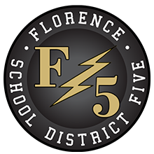

**Florence County School District Five Board of Trustees**

**152 East Marion Street, Johnsonville, SC**

**Monday, October 24, 2022, 7:00 p.m.**

1. **Call to Order, Welcome, and Pledge of Allegiance**
2. **Confirmation of Notice to Media**
3. **Approval of Agenda**
4. **Public Forum**

**5. Consent Agenda**

A. Minutes – September 26, 2022 – pp. 1-3

B. Monthly Financial Statement – September 2022 – pp. 4-5

**6. Regular Agenda**

A**. Superintendent’s Report**

1. Academic Updates – Mr. Brian Goins

2. Upcoming Events and Updates

**7. For Action Agenda**

A. Second Reading of Policy IHBF (Medical Homebound Instruction) – p. 6

**8. Executive Session Agenda**

A. Personnel Resignation

**9. Reconvene in Open Session with Action if Necessary from Executive Session**

**10. Adjournment**

 Joshua B. Timmons, Chairman

*The Morning News/NPO*

*WMBF-TV*

*WPDE-TV*

*WBTW News*

*www.fsd5.org*