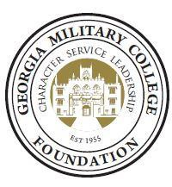

Warner Robins Campus

Scholarship 2022-23

Note: Recipient of this scholarship should have the following criteria:

- A member of Robins Financial Credit Union

- A student attending Georgia Military College – Warner Robins Campus

- Demonstrate financial need

- Must maintain a full course load (minimum of 12 hours)

- Must maintain a GPA of 2.0 of higher

Name:

Last: First: Middle

Permanent Home Address:

City: State: Zip: County:

Telephone:

Mailing Address (If different from above):

GMC Student ID:
Date of Birth:

Major Area of Educational Interest:

