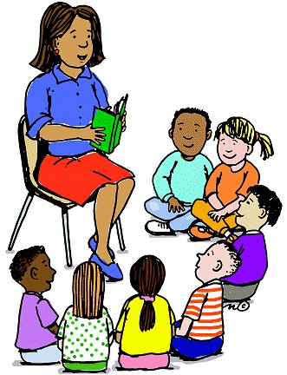

**Counselor’s Newsletter**

***Ms. Cunningham***

***September 2022***

**Dear Parents/Guardians,**

This month’s lessons will be about Getting Along With Others and Diversity. These lessons teach students about tolerance, acceptance, and friendship. Students learn that with differences comes knowledge.

**News**

Parents/guardians the ordering for our Bullying T-Shirts started last week. By ordering bullying t-shirts, you are supporting our mission of preventing bullying in our schools. Ordering information was sent out via school’s website and Facebook Page.

**Important Dates**

9/5-Labor Day-No School

9/13-Title 1 Meeting-5:00-5:30

9/13-Open House-5:30-7:00

9/15-Fall Pictures

9/22-Clubs Start

**Monthly Character Word**

**Cooperation**

Cooperation is working together peacefully to reach the same goal, it means helping others so that everyone can succeed, it is **teamwork**. Students show cooperation when they work in small groups to complete or accomplish a task. You show it when you allow each person in the group to have a say, when everyone is able to share their ideas, and when you try to use everyone’s idea and do your fair share of work. We often show cooperation in our everyday lives, whether its in sports or work with classmates.