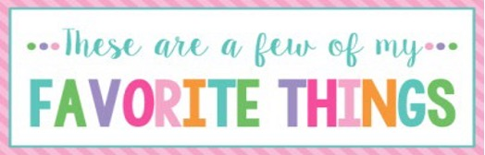

Name: | Bailey Simmons | T-Shirt Size: | XL
Birthday: | September 1st | Monogram: | BJS
Favorite Color: | Blue | Favorite Flower: | Magnolia
Favorite Scent: | Teakwood or Cashmere | Favorite Candy: | Reese’s PB Cups (or anything with chocolate)
Favorite Drink: | Chocolate milk | Favorite Food: | Steak
Favorite Snack: | Pickles | Favorite Fruit: | Watermelon or peaches
Favorite Restaurant: | Longhorn Steakhouse | Favorite Fast Food: | Chick-fil-A
Favorite Places to Shop: |  | American Eagle, Hobby Lobby, Dick’s Sporting Goods
Favorite Bath & Body Works Scent: |  | Sweater Weather
Things I Collect: |  | Books, wax melts, snow globes
Favorite Author/Book Series for Personal Reading: |  | Nicholas Sparks
Wish List for Classroom: |  | KickBands, Post-It Easel Pads, 3x5 rug, marble run, marbles, dice, individual whiteboards, whiteboard erasers, dry erase pocket sleeves, Jason Chin books, Geography board games (national parks, U.S. states, etc.)

