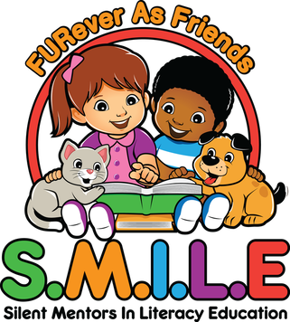
Hosted at the Gill Memorial Library, check out our Facebook page for date and time announcements!
The SMILE Program is geared towards children who need more confidence in reading. A team consisting of a handler and a pet (dog, cat, bunny) will visit the contracted location for approximately 60 minutes to 2 hours. Children typically spend 5-15 minutes one-on-one with a pet. Each reading session is dependent upon the child’s attention span and skills.
Purpose: Children sit and read to a cuddly, comforting animal to improve their literacy, inflection, communication, and vocabulary skills while boosting their attention span and confidence.
Time: 5-15 minutes per child for a reading session. The maximum amount of children is usually around 5-8 per session to prevent distractions.

This facility has contracted with FURever As Friends, INC who will provide pet therapy services/visitations. The therapy teams are covered with liability insurance and all of the animals have successfully completed the FAF/AKC Good Citizenship test.
All of the handlers have been thoroughly trained how to properly and safely handle the animals in settings similar to this facility.
All vaccinations for the animals will be on record at the facility where the service will be conducted.
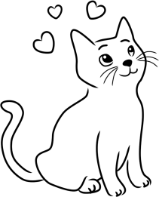
FAF shall be allowed to photograph during their visits and any such photographs shall become property of FAF in order to publish, duplicate, reproduce, and make use of the photography for marketing and promotional material.
By signing this permission slip, you agree you have read and understand the terms for participation in this program and to hold FURever As Friends and their therapy teams, harmless from any claim that arises out if your participation in the program, except for any claim arising out of negligence or misconduct of FURever As Friends or any volunteer.

Your participation in this program will not begin until your written permission is given. In the interest of your safety, we cannot offer participation to you if they are allergic or afraid of dogs, cats, or rabbits.
Guardian Signature | Email (Optional)
Participants
1. | 2.
3. | 4.
5. | 6.
Please supply your email address so FURever As Friends can provide you with news updates, and activity list for the organization.

