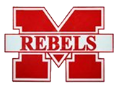

April 25, 2024

To the Parents of McKenzie Special School District:

Easily pay for school meals online from now on. Create your free MySchoolBucks account to conveniently and securely add money to your student’s meal account online or with the mobile app.

With MySchoolBucks you’ll be able to view cafeteria purchases, check your student’s balance, receive low balance alerts, and pay for school meals from anywhere!

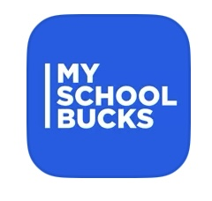**Get Started Today:**

1. Go to myschoolbucks.com or download the mobile app.

2. Create your free account and add your students using their school name/ birthdate.

3. Add funds using your credit/debit card or electronic check. For each transaction, you will be charged a program fee of $2.49 for electronic checks and $2.75 for credit/debit cards. (A transaction can include multiple students.)

4. Set up automatic payments and never forget to send in lunch money again!

We appreciate you using this online tool as a way to help reduce the amount of physical cash and check handling that would typically happen in the serving line. **It also allows for parents to keep a check on transactions and account balances.**

If you need assistance with your account, you can find helpful how-to videos and answers to commonly asked questions by visiting myschoolbucks.com. Or, you can contact MySchoolBucks directly by logging into your account to start a chat conversation or give them a call at (855) 832-5226.

Thank you!

**Greg Jones- Food Service Director**