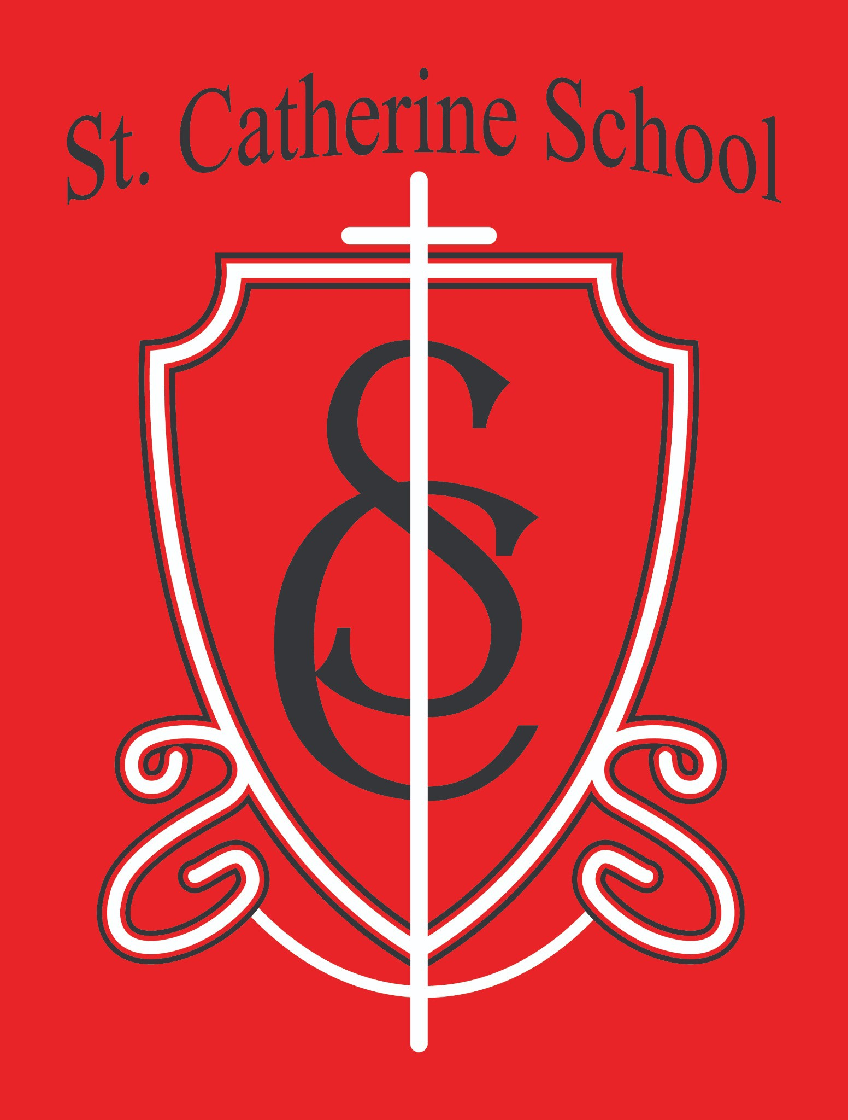

St. Catherine School Weekly Newsletter (Week of February 16-21)
https://www.stcatherine.k12.nd.us/parents

Principal's Message
Dear St. Catherine Families,
As we enter the Season of Lent, our focus as a Catholic school shifts intentionally toward prayer, sacrifice, and preparation for Holy Week.
Lent is not simply a season where we “give something up.” It is meant to be a season when we build something deeper — a discipline of the heart, strength of character, and greater love for Christ. We hope that is also a lesson that we can reinforce here at school.
Each Wednesday during Lent, our students will pray the Stations of the Cross during chapel. We walk step by step with Jesus on His journey to Calvary. We speak openly about His sacrifice. We reflect on what it means to carry our own crosses with faith. We prepare intentionally for Holy Week — not casually or hurriedly, but thoughtfully.
This year, our virtue focus during Lent aligns beautifully with that journey:
Magnanimity – Greatness of soul. Responding generously when God calls us to grow.
Patience – Bearing small difficulties calmly.
Meekness – Strength under control.
These virtues form the interior life. They help students understand that fasting, prayer, and almsgiving are not punishments — they are formation. They are training for the heart.

At St. Catherine School, building the faith means:
Teaching students how to pray, not just when to pray. Helping them understand sacrifice, not just talk about it. Connecting behavior expectations to virtue.
Forming habits of self-control, charity, and humility.
Lent is one of the most powerful formation seasons of the entire school year. Thank you for reinforcing these conversations at home as we journey toward Easter together.

Reminders

Kindergarten Round Up -

Next Friday - February 27th, from 8:45-10:00. Please RSVP for you and your kindergarten child if you can attend. Current families, it is nice to have a good showing of current families at Kindergarten round-up - even if you already know your child will be attending. New families are more comfortable when they know current families' perspectives.

All School Mass – March 5 (Guest Lunch to Follow)

Our next All School Mass will be held on March 5, followed by a guest lunch.

If you plan to attend and join your child for lunch, please RSVP to the school office so we can plan accordingly.

No School – March 6 and March 9

There will be no school on Friday, March 6 and Monday, March 9. Please plan accordingly.

End of Quarter 3 – March 13

Quarter 3 ends on March 13. It is hard to believe how quickly the year is moving. Thank you for helping your students stay focused and finish the quarter strong.

St. Catherine Spotlight
Our Substitute Teachers
We are incredibly blessed with substitute teachers who are willing to step into classrooms when needed. Over the past couple of weeks, we have had a few teachers out of the building, and school continued right along without missing a beat. That does not happen without capable,

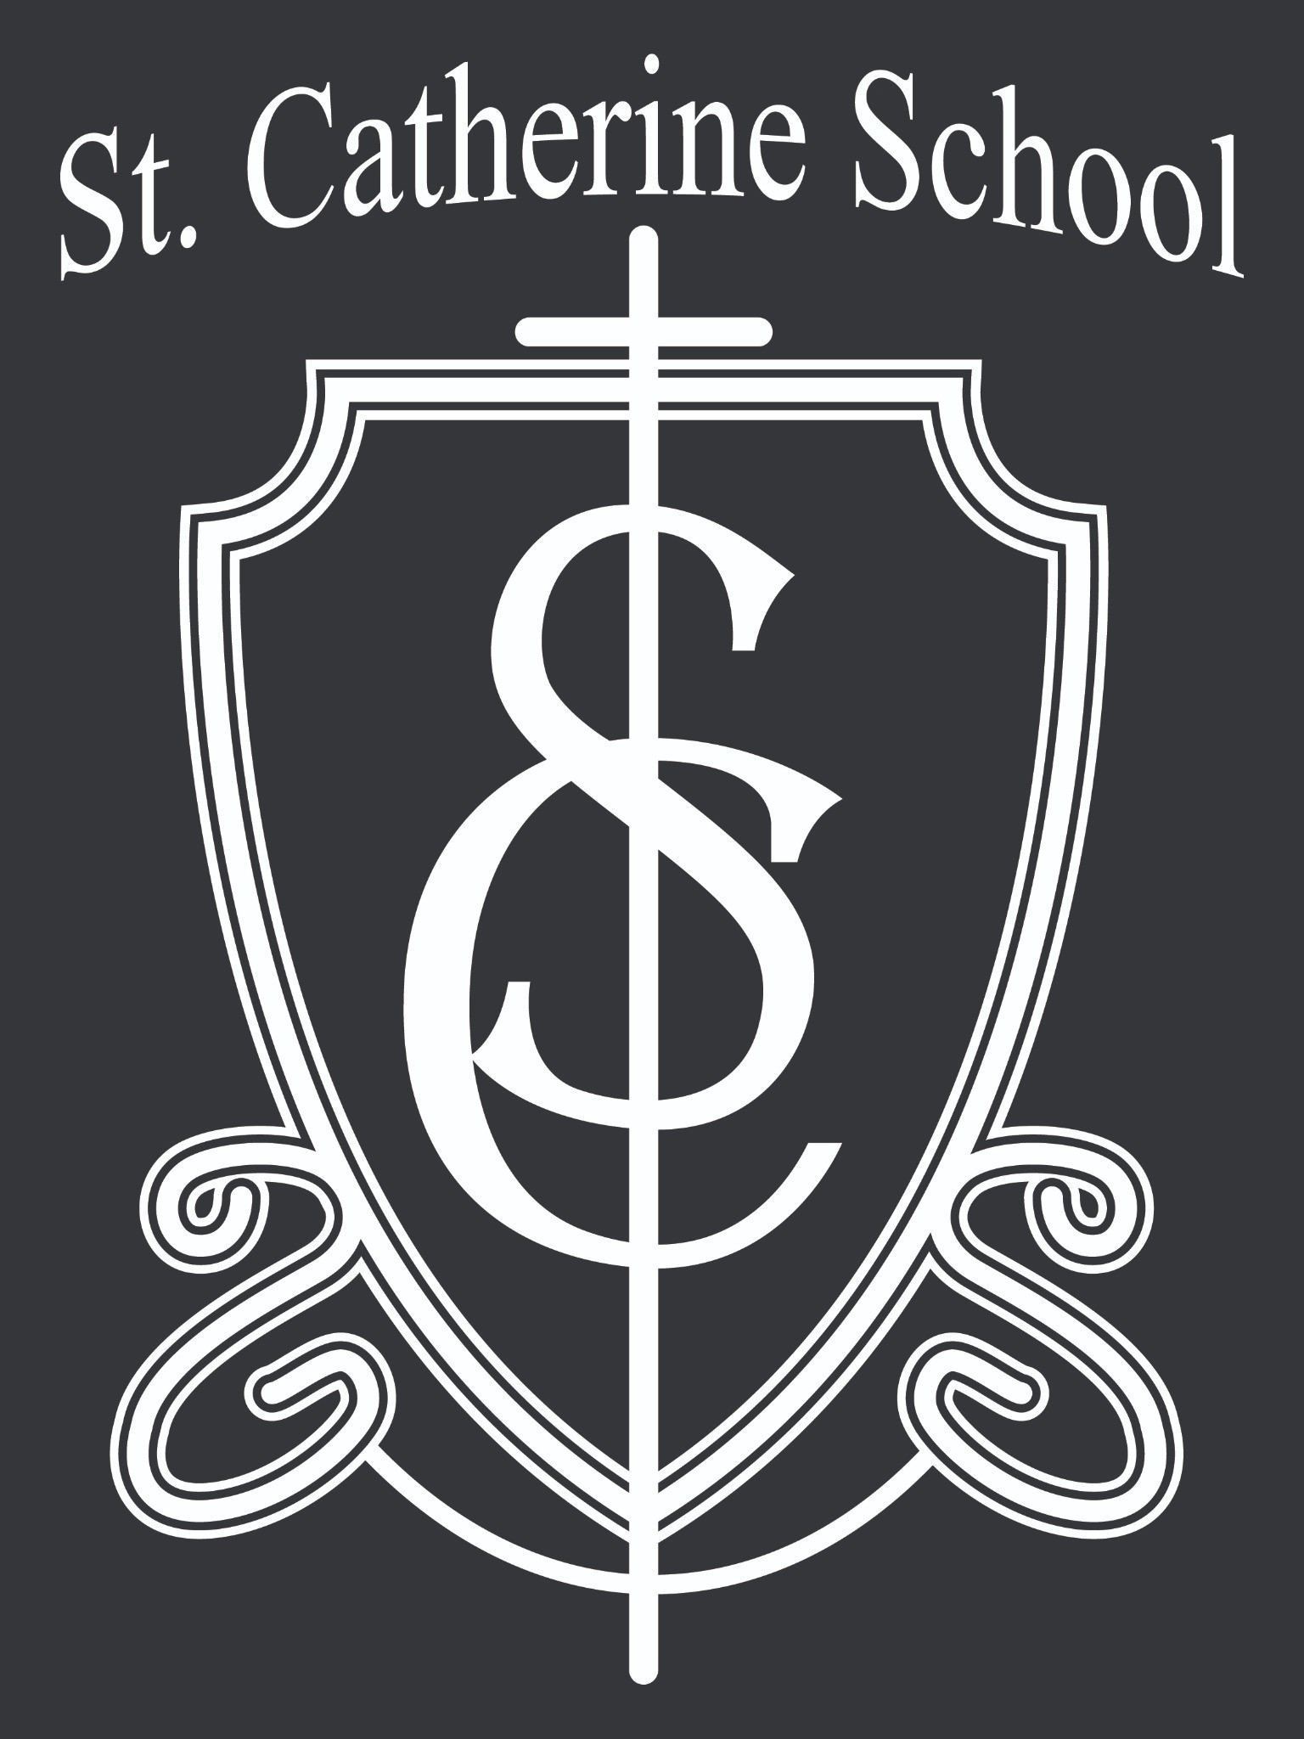steady individuals willing to say “yes” when called. We are grateful for their flexibility and commitment to our students.

5th & 6th Grade Band
I had the opportunity to observe the 5th- and 6th-graders during Band on Friday. Regardless of the complaints you might occasionally hear at home, I can assure you they were working very hard and smiling at their successes. There is something about music that engages students in a way other content areas do not always reach. It builds discipline, perseverance, teamwork, and confidence. It was a joy to watch them grow in both skill and pride in their work.

Stay Connected with St. Catherine School
📍 Address: 540 3rd Ave. NE, Valley City, ND 58072
Email: nicholas.lee1@k12.nd.us
📧
Phone: 1-701-845-1453
📞
Website: www.stcatherine.k12.nd.us

🌐
📘 Follow Us on Facebook: St. Catherine School on Facebook

“Inspiring excellence through faith, learning, and service.”

