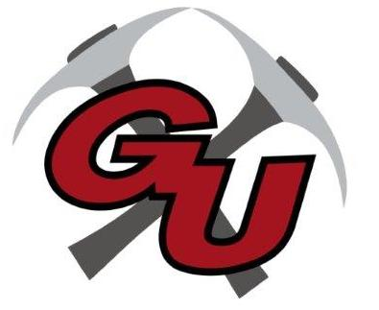
Grant Union Prospectors
Junior High Boys Basketball 2022

DATE OPPONENT SITE TIME DISMISS DEPART
11/4 Union GU (Humbolt) 11:00am
11/8 Prairie City PC 4:00 2:45 3:00
11/10 Burns GU (HS Gym) 4:00 3:00
11/18 Crane Crane 12:00 9:00am
11/19 Burns Burns 11:00am 8:00am
11/22 Heppner Heppner 4:00 11:45 12:00
11/29 Crane GU (Humbolt) 4:00 3:00
12/6 Baker Baker 4:00 12:45 1:00
12/9 Prairie City GU (HS Gym) 11:00am
12/13 Baker GU (HS Gym) 4:00 3:00

