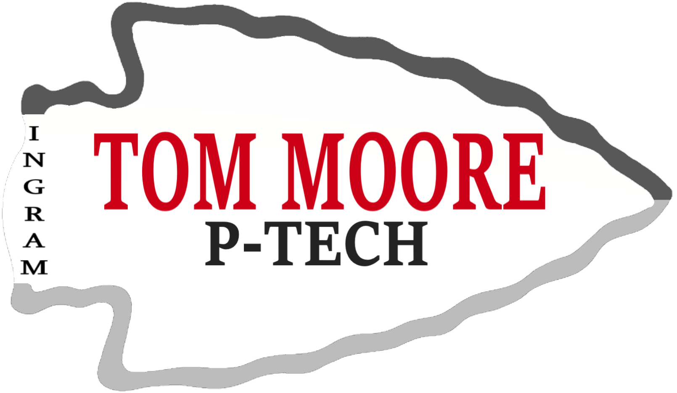

Partner with Ingram ISD P-TECH
Help Shape the Future Workforce

About the Program
Ingram ISD P-TECH (Pathways in Technology Early College High School) is an open enrollment program for all ITM students in grades 9-12
Students:
- Work toward an associate degree or a career industry certification
- Gain hands-on, real-world experience
- Build skills for high-demand, high-wage careers in our community and beyond
- Graduate with career-ready skills

Why Partner with Us?
Partnering with Ingram ISD allows your business to:
- Support student success
- Build a future workforce pipeline
- Strengthen the local community
- Connect with motivated, career-ready students

Ways to Get Involved
- STUDENT MENTORING
Provide guidance, career awareness, and skill development
- JOB SHADOW DAY
Host students for 2–4 hours at your workplace
- INTERNSHIPS
Offer paid or unpaid real-world work experiences
- GUEST SPEAKERS
Share your expertise with students on campus

Get Involved today!
Interested in partnering with Ingram ISD? Click the link below and tell us who you are, what your business is, and how we can contact you. INTEREST LINK

