Mr. Mattox Course Syllabus
2023-2024 (Semester 1)

Motivation + Hard Work = Success

Instructor Information
Course: Algebra I with Probability or Algebra II with Statistics
Room #: A24
Contact: Message through ParentSquare or email to “jason.mattox@acboe.net” or call the school at 334-387-1910.
Also visit www.marburyhighschool.org and click on “Faculty & Staff” to view teacher bio, class schedule, lesson plans.

Student Class Supplies
- Mechanical or #2 pencils (hand held sharpener might also be beneficial)
- Extra erasers just in case they are needed
- 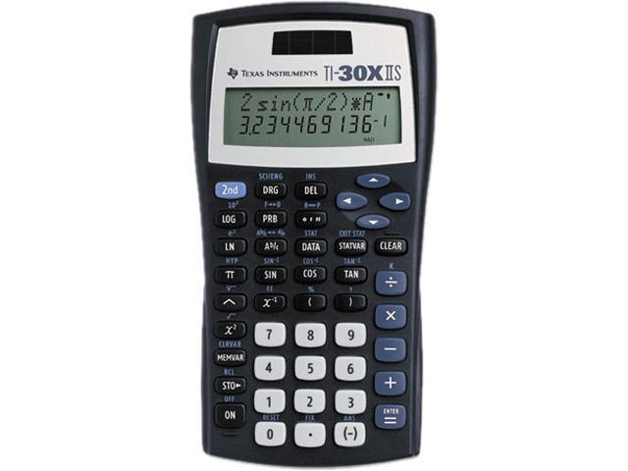3-ring binder with college ruled loose-leaf paper and tab dividers to stay organized or notebook and folder to stay organized
- 12” ruler for creating data tables and graphs
- Pack of colored pencils for creating foldables and graphic organizers
- Recommended personal calculator: “Texas Instruments TI-30X IIS”
at Walmart or Office Depot for around $15. This calculator comes in
multiple colors and operates easily and will enable students a smoother
transition for future math classes. (the TI-84 Plus CE is an expensive
graphing calculator for around $100 that provides many features if you are
interested in making an investment that will also carry into more advanced math courses/college)

Teacher Wish List (optional donations that would be greatly appreciated)
White copy paper, color copy paper, graph paper, tissues, 13 gallon trash bags, AA and AAA batteries, disinfecting wipes, college ruled loose leaf paper, paper towels, pre-sharpened #2 pencils

Textbooks
There will be a classroom set of textbooks that will be used throughout the course, but will be kept in the classroom. Students may check out a book if desired and are responsible for the condition of the textbook while in their possession. These books are fairly new so lost or damaged textbooks will result in a fee if applicable.

Grading Policy
Student grades will be updated on a regular basis through “PowerSchool”. Averages are weighted following Autauga County Board of Education policy and all assessments are based on a 100 point system. The grading scale used is as follows: A=90-100, B=80-89, C=70-79, D=60-69, F=0-59. Grades of 0.5 or higher will round up.

- Major Grades – 65%
Could be standard specific test, mid-unit test, or end of unit test.
- Minor Grades – 35%
Could be a quiz, homework assignment, or classwork participation grade.

I will be glad to inform a student of their current average at anytime if they want to know.
A midterm exam counting 20% will be taken ending the 1st nine weeks with no exemptions possible.
A final exam counting 20% will be taken ending the 2nd nine weeks with exemptions possible based on the
Board of Education policy for semester averages and absences (A – at most 5 absences, B – at most 3 absences).
Final course average is determined by 50% from 1st nine weeks and 50% from 2nd nine weeks.

Make-Up Work
If a student has an absence from class, they are responsible to stay caught up in the curriculum by asking for missed assignments and will have three days to turn in an excuse. Assessments with excused absences are allowed to be madeup but will result in half credit if submitted late. Makeup assessments not submitted will result in a zero recorded in the gradebook. Unexcused absences will result in a zero for any assessments missed.

Daily Schedule
Our normal routine will begin with a “Before” activity like a bellringer and turning in any homework. This time is used to refine yesterday’s material or to spiral review a specific concept to activate background knowledge. New material will then be presented using a “During” activity through instructional examples and strategies followed by guided practice. Some days will consist of partner work, interactive activities, games, or other instructional strategies to reinforce learning. On most days there will be some kind of summarizing activity or “After” assessment at the end of class to check for understanding and help drive instruction for the next day. Multiple strategies and activities will be used for application during the learning process.

Classroom Behavioral Expectations ----------3 R’s: Respectful, Responsible, Resourceful
- Demonstrate respect for others
“A good attitude is a little thing that makes a big difference in your life”

- No inappropriate items including electronic devices, food, drink,
Unless otherwise stated by the teacher
- Be on time, prepared, and responsible for your work
- Be honest and have integrity in your work
- Keep area clean and use trash can
*Always be mindful of and adhere to the school policies in the student handbook.

Four-Step Discipline Policy (Some actions may cause steps to be skipped)
When behavior issues arise, the following system will be followed with documentation in order to address the issue:
- Teacher warning/individual conference with student
- Stop and Think Form
- Communication with parent
- Office referral
*These steps also apply to being tardy to class and phone misconduct.

Tutoring Available
I am willing to spend more time with a student before school or during Bulldog Period in order to help him or her become more confident in their work and get closer to mastery of material they may be struggling with. Please ask if interested in receiving this additional help outside of the designated class time.

Algebra I with Probability Course Description
This course is designed to emphasize the study of multiple algebraic representations. Algebra I critical standards consist of properties of exponents, recognizing structure in expressions, factoring to reveal zeros, using the vertex form, expressions for exponential functions, polynomial expressions, completing the square, two variable equations, systems of equations and inequalities, using function notation and evaluate, graphing solutions to linear inequalities, properties of function, graphical transformation, bivariate categorical data, association between categorical variables, two way tables, independent events, and describing conditional probability. Each standard will be addressed at a greater depth with various embedded concepts that build upon prior knowledge. Students who complete Algebra I will be equipped with the foundational knowledge in preparation for higher level math courses and the Pre- ACT test.

Algebra II with Statistics Course Description
This course is designed to emphasize the study of multiple algebraic representations. Algebra II power standards consist of reviewing advanced algebra; linear relations and functions that can be quadratic, polynomial, or radical; advanced functions and relations; trigonometry; solving real-world problems; and analyzing data using statistics. Each standard will be addressed at a greater depth with various embedded concepts that build upon prior knowledge. Multiple strategies and activities will be used for application during the learning process. Students who complete Algebra II with Statistics will be equipped with the foundational knowledge in preparation for higher level math courses and the ACT test.

