

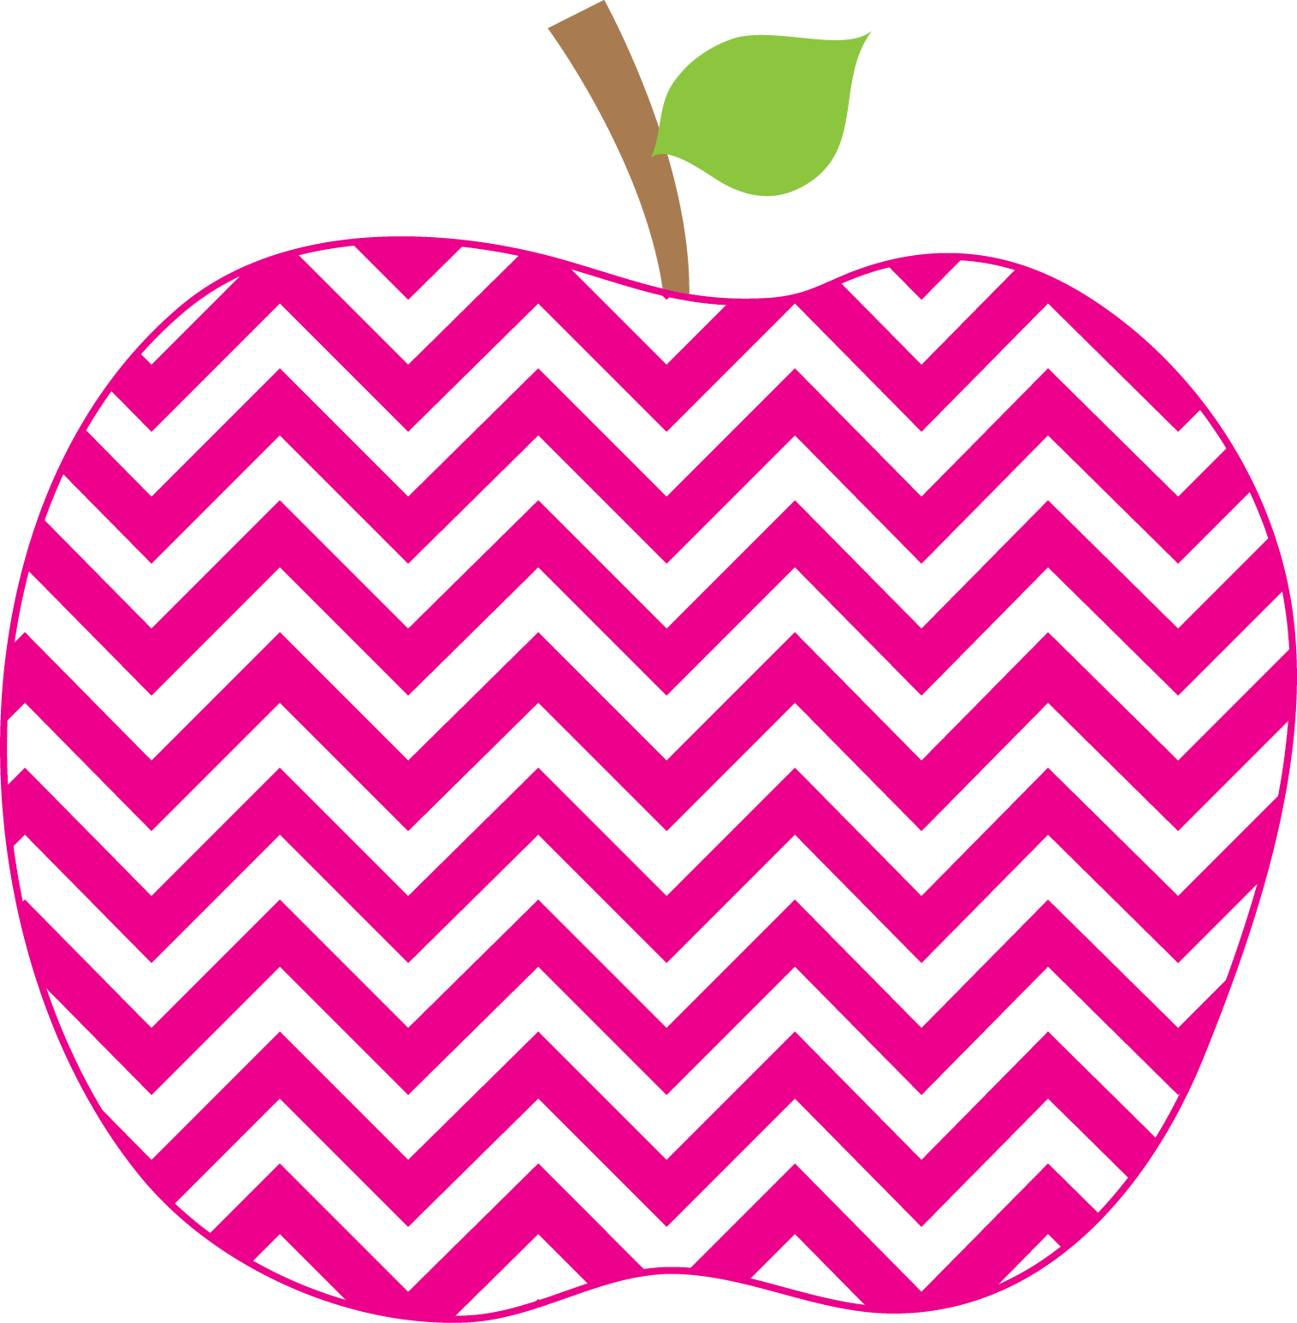



E. Robinson Weekly
Ms. E

March 31, 2025

Reading:
Pond Plants/ Fruits and Vegetables at Work

Phonics Skills:
* /m/ spelled mb, /n/ spelled kn, gn
* /r/ spelled wr, /f/ spelled ph

High-Frequency Words:
know how want now saw old would one

Spelling/Dictation Words:
lamb limb comb thumb wrap
wrong know knob knee saw

Grammar Skill: Possessive Pronouns
Math:
*Subtracting Tens and Ones

Social Studies/Science- The Solar System
This Week’s Focus:
Story for the Week:

Star Apple of the Week:
No Star Apple
* Please make sure that you are helping your child with his/her homework each night. Some of the students are not doing well on their weekly spelling tests.

Wednesday, April 16th Class Picnic @ 11:43
Progress Reports

Friday, April 18th Teacher Work Day/
No School for Students

Friday, April 25th Bulldog Binder Day/ Numeracy Day

Reminders:
Important Dates:

