FY 2024-2025

Clay County School Nutrition

Welcomes

All Students Back To School

Featuring

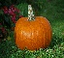 (NSLP) National School Lunch Program

Fresh Fruit & Vegetable Program

School Meal Standards

