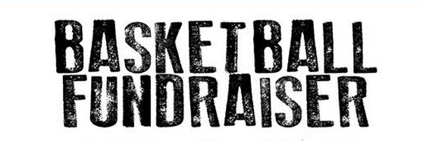

The RCHS Boys Basketball team will be doing another Pepsi Fundraiser to help raise funds for basketball team camp at Liberty University. The fundraiser will go until May 20th and drinks should be delivered in time for any Memorial Day or graduation parties! Drinks can be ordered using the link below and payments can be given to Colton Ball at RCHS or Jennifer Deal at RCES. Thanks for your support of the boys basketball team.

https://docs.google.com/forms/d/1km0ExdTfC3MRZ-sWovBhL3itZy7ec4b_7Sh3lbaZDAw/edit

