

Chicken Wrap

Hamburger Steak

Mashed Potatoes

Fruit/Milk/Roll

Grilled Cheese

Ham/Cheese Sliders

Chips/Green Beans

Frui/Milk

Chips/

Lunchable

Burritos

Corn/Rice

Fruit/Milk

Turkey Sandwich

Hotdog/Chips

Green Beans

Fruit/Milk

Chicken Wrap

Chicken Nuggets

Waffles/Carrots

Fruit/Milk

Lunchable

Tacos

Chili Beans/Salsa

Fruit/Milk

Turkey Sandwich

Chicken Sandwich

Green Beans

Fruit/Milk

Turkey Sandwich

Sloppy Joe

Chips/Corn

Fruit/Milk

Grilled Cheese

Eggs/Grits/Toast

Sausage/Hashbrown

Fruit/Milk

Chicken Wrap

Chicken Alfredo

Green Peas/Roll

Fruit/Milk

Turkey Sandwich

Cheeseburger

Fries

Fruit/Milk

Grilled Cheese

Cheeseburger Mac

Carrots/Roll

Fruit/Milk

Lunchable

Nachos

Refried Beans/Salsa

Fruit/Milk

Soybutter Sandwich

Pizza

Mixed Veg.

Fruit/Milk

Soybutter Sandwich

Pizza

Carrots

Fruit/Milk

Soybutter Sandwich

Pizza

Mixed Veg.

Fruit/Milk

Soybutter Sandwich

Pizza

Corn

Fruit/Milk

Chicken Wrap

Chicken Nuggets

Broccoli&Cheese

Fruit/Milk/Roll

Lunchable

Chicken Fajitas

Chili Beans/Rice

Fruit/Milk

]

Menu IS SUBJECT TO CHANGE

CNP IS AN EQUAL OPPORTUNITY EMPLOYER

Grilled Cheese

Spaghetti/Roll

Green Peas

Fruit/Milk

**SEPTEMBER 2025**

PRATTVILLE KINDERGARTEN

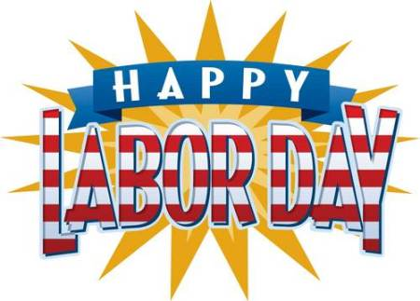

Lunchable

Quesadilla

Chili Beans/Salsa

Fruit/Milk