QR Exploration
(Use the camera app and the website will come up. Click on the website.)
Phonics Man- YouTube Mister B- YouTube The Electric Company-
Youtube 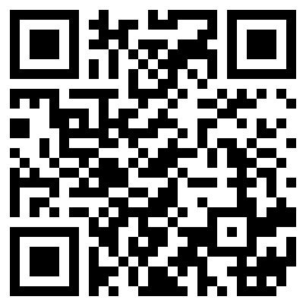

Teach your monster NumberBlocks- Jack Hartman
to read YouTube

Storyline Online PBS Kids Story Time

