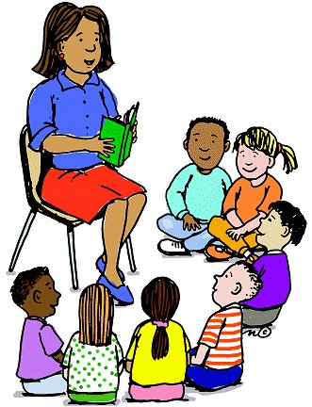

**Counselor’s Newsletter**

***Ms. Cunningham***

***December 2022***

**Dear Parents/Guardians,**

This month’s lesson will be about being Kindness. Kindness goes a long way, especially in the times we are living in today. Students will learn and demonstrate empathy through our kindness lesson. By students showing kindness, it gives them a chance to show and receive kindness back. They will learn that it takes little effort to smile at someone, hold the door, or even compliment others, in doing so students can experience positive mental and physical changes through and feel good about themselves in doing good for others.

**News**

During this time, we will be celebrating and giving back to our community through our toy donations. Students will have more than a two-week break. Parents and guardians please encourage your students to take some time over the break to read and practice in areas of their education where they need the extra help, also prepare them to come back to school in the new year refreshed and ready to work!

**Important Dates/Events**

**Christmas Pictures 5th**

**Christmas Play 8th**

**Club Day-15th**

**Polar Express Day 15th**

**Christmas Parties 16th**

**Pep Rally 16**

**Christmas Break 12/19-1/4**

**Monthly Character Word**

**Kindness**

As I have stated before, kindness goes a long way! There’s a saying, “You can catch more flies with honey, then vinegar”, meaning you will have more success if you go about things with sweetness or with a positive attitude than with acidity or negativity. Being courteous, polite, and respectful is not only a good way to show that you have manners and are respectful, but that you are a kind person as well. So, let’s not be hurtful or acidic, but uplifting and sweet!