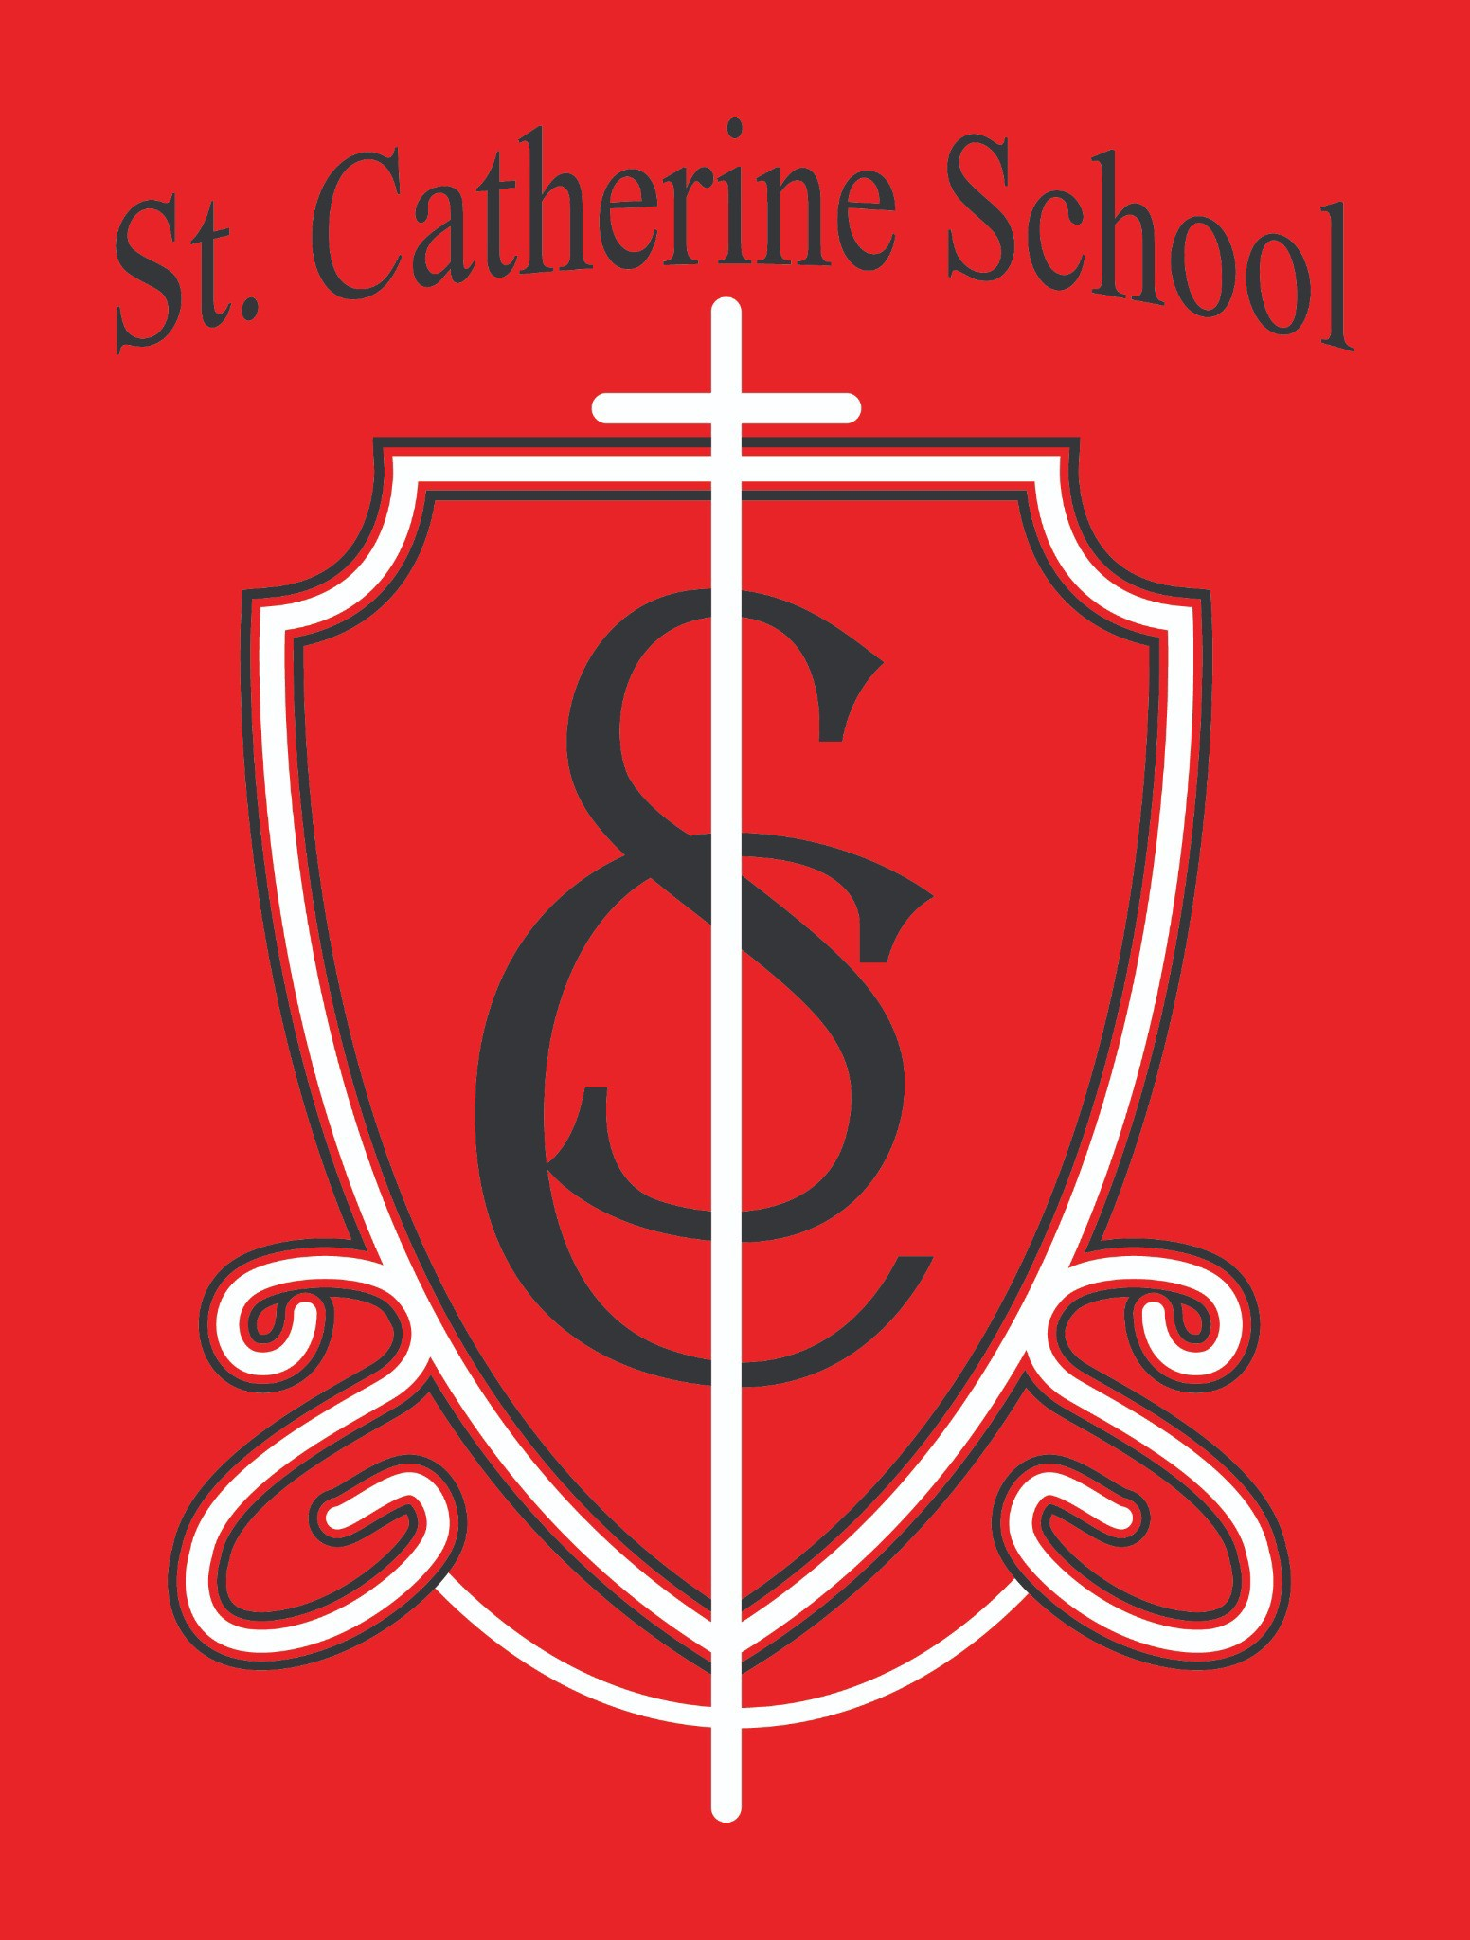

St. Catherine School Weekly Newsletter (Week of September 29-October 3rd)
https://www.stcatherine.k12.nd.us/parents

Principal's Message
Dear St. Catherine Families,
My apologies—this email was meant to go out on Friday but got stuck in my outbox. Thank you for your understanding!
The 53rd Annual St. Catherine School Fall Auction is right around the corner, and it stands as one of the most important and impactful events of our year. This event doesn’t just raise money—it strengthens our community and ensures that Catholic education remains affordable and vibrant in Valley City.
The auction supports so much of what we do. This past year, funds helped: Contribute to the operating budget of the school
Purchase new devices for staff and students Fund our new reading curriculum
Provide reading incentives and prizes for students
Support teacher classroom needs and many other essential projects

It’s a beautiful example of what can happen when a community of faith comes together with generosity and purpose. I’m incredibly thankful to all the parents, parishioners, and local

businesses who give of their time, talent, and treasure to make this event possible year after year.

If you haven’t yet reached out to the businesses on your list, please do so soon. In the coming weeks, we’ll also be seeking volunteers for the Fall Auction Kick-Off Breakfast—please watch your email for more details.
Every hand that helps makes a difference. Thank you for continuing this incredible tradition of service and support for our students and our mission.

Reminders
Parent–Teacher Conferences – Thursday, October 9
Parent–Teacher Conferences will be held Thursday, October 9. A schedule was emailed out by Ms. Giesen. If you did not receive it, please contact the school office at 701-845-1453 or terra.giesen@k12.nd.us.
Book Fair – This Week!
The Book Fair runs this week from 8:00 AM–4:00 PM and during Parent–Teacher Conferences. Students shopping in the mornings will need cash. Teachers have classroom wish lists, and each sale supports our school library—a wonderful opportunity to pick up gifts or donate books for classrooms!
No School – October 16–17
There will be no school on Thursday, October 16, as staff will attend the Fargo Diocese In- Service Day.
There will also be no school on Friday, October 17 for Parent-Teacher Compensation Day.
Support the School – Did You Know?
Trimming Our Family labels and turning them into the church office, school office, or CDA corner in the church basement helps support our school’s mission.
A big thank you to the Catholic Daughters for organizing this ongoing effort! Every label helps—our family keeps a bag on the fridge for clipping labels.
Weather & Dress Code Reminder
As the temperatures drop, please remember that per the school handbook, shorts are not to be worn after October 1st. Last week’s weather was beautiful, so we extended the shorts window a bit, but today’s high is only around 50 degrees, which is a good reminder to bring out fall and winter clothing. Please ensure your child comes to school dressed appropriately for outdoor recess.

St. Catherine Spotlight
We had a great auction planning meeting this week—thank you to the amazing parents who continue to give their time and creativity to make our school’s largest fundraiser a success. Your efforts truly help sustain our mission.

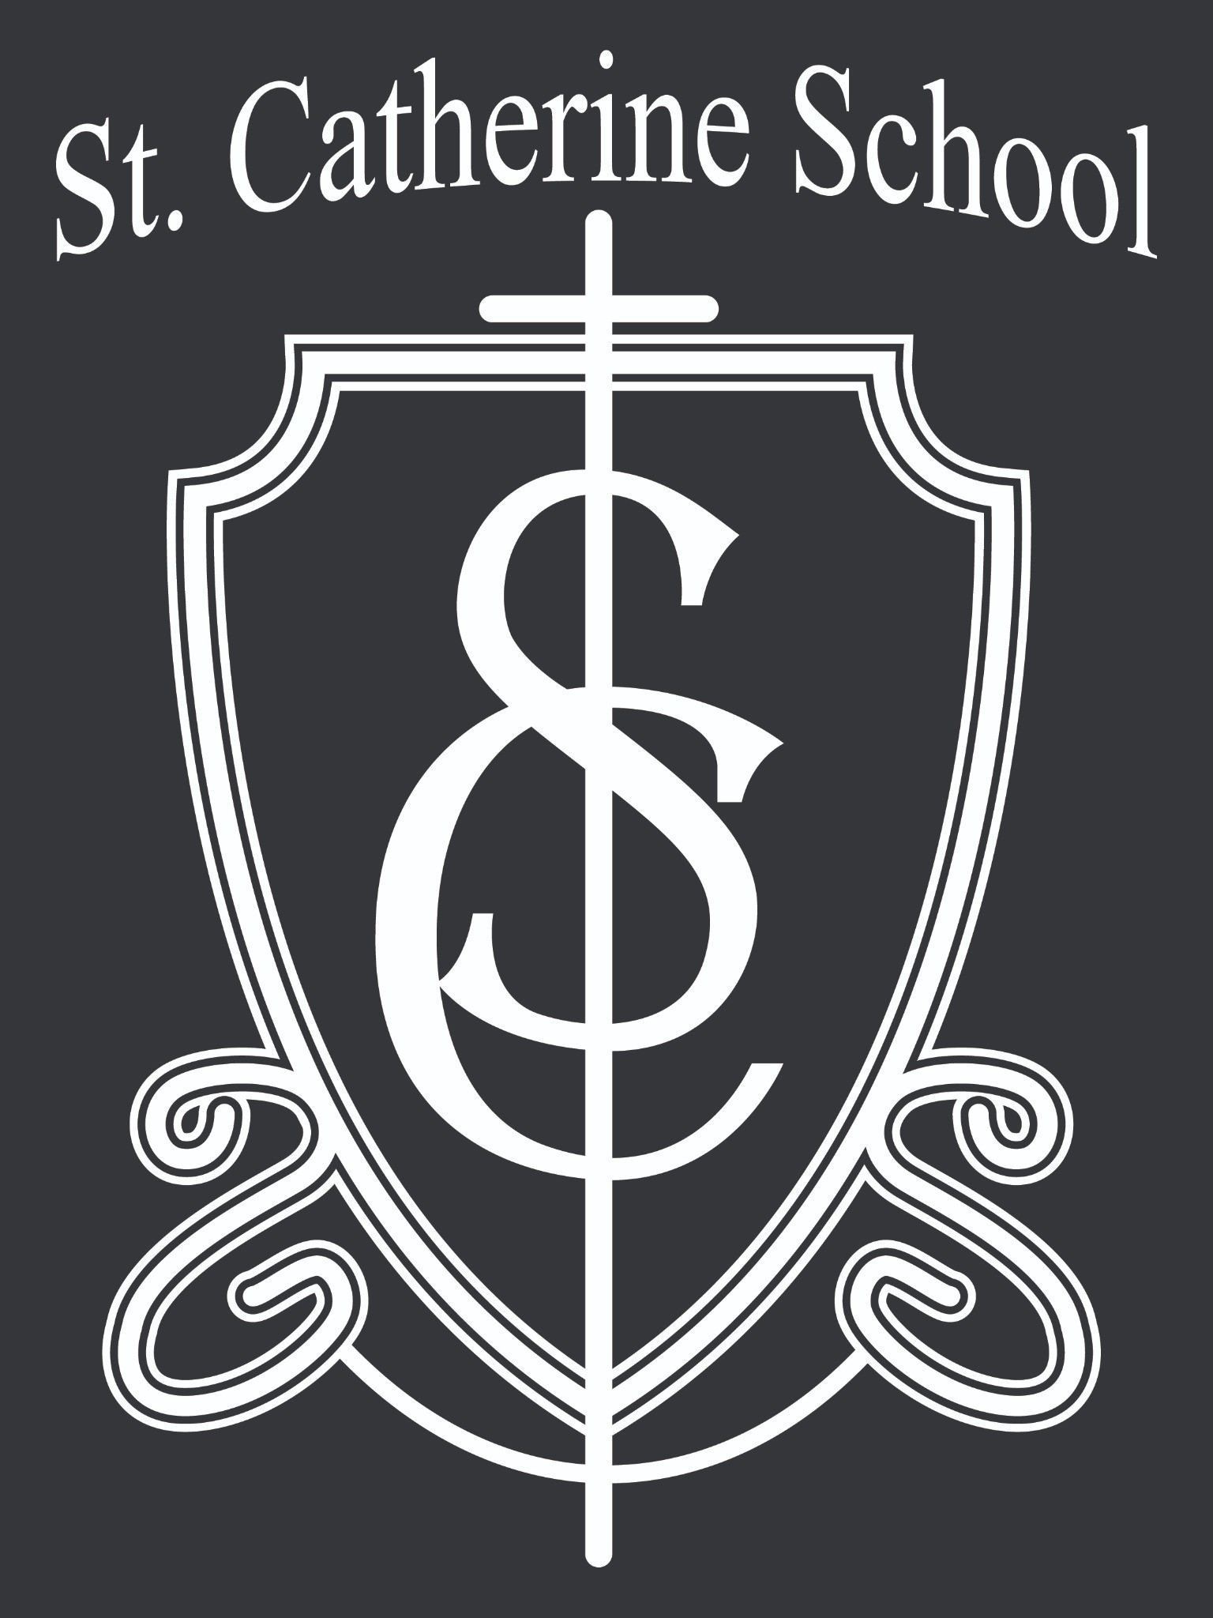We also witnessed a 6th grader showing deep understanding and faith by answering some tough questions during chapel about the Theological Virtues and how Baptism connects to them. It’s moments like these that remind us why faith formation is at the heart of everything we do.

Stay Connected with St. Catherine School
📍 Address: 540 3rd Ave. NE, Valley City, ND 58072
Email: nicholas.lee1@k12.nd.us
📧
Phone: 1-701-845-1453
📞
Website: www.stcatherine.k12.nd.us
🌐
📘 Follow Us on Facebook: St. Catherine School on Facebook

“Inspiring excellence through faith, learning, and service.”

