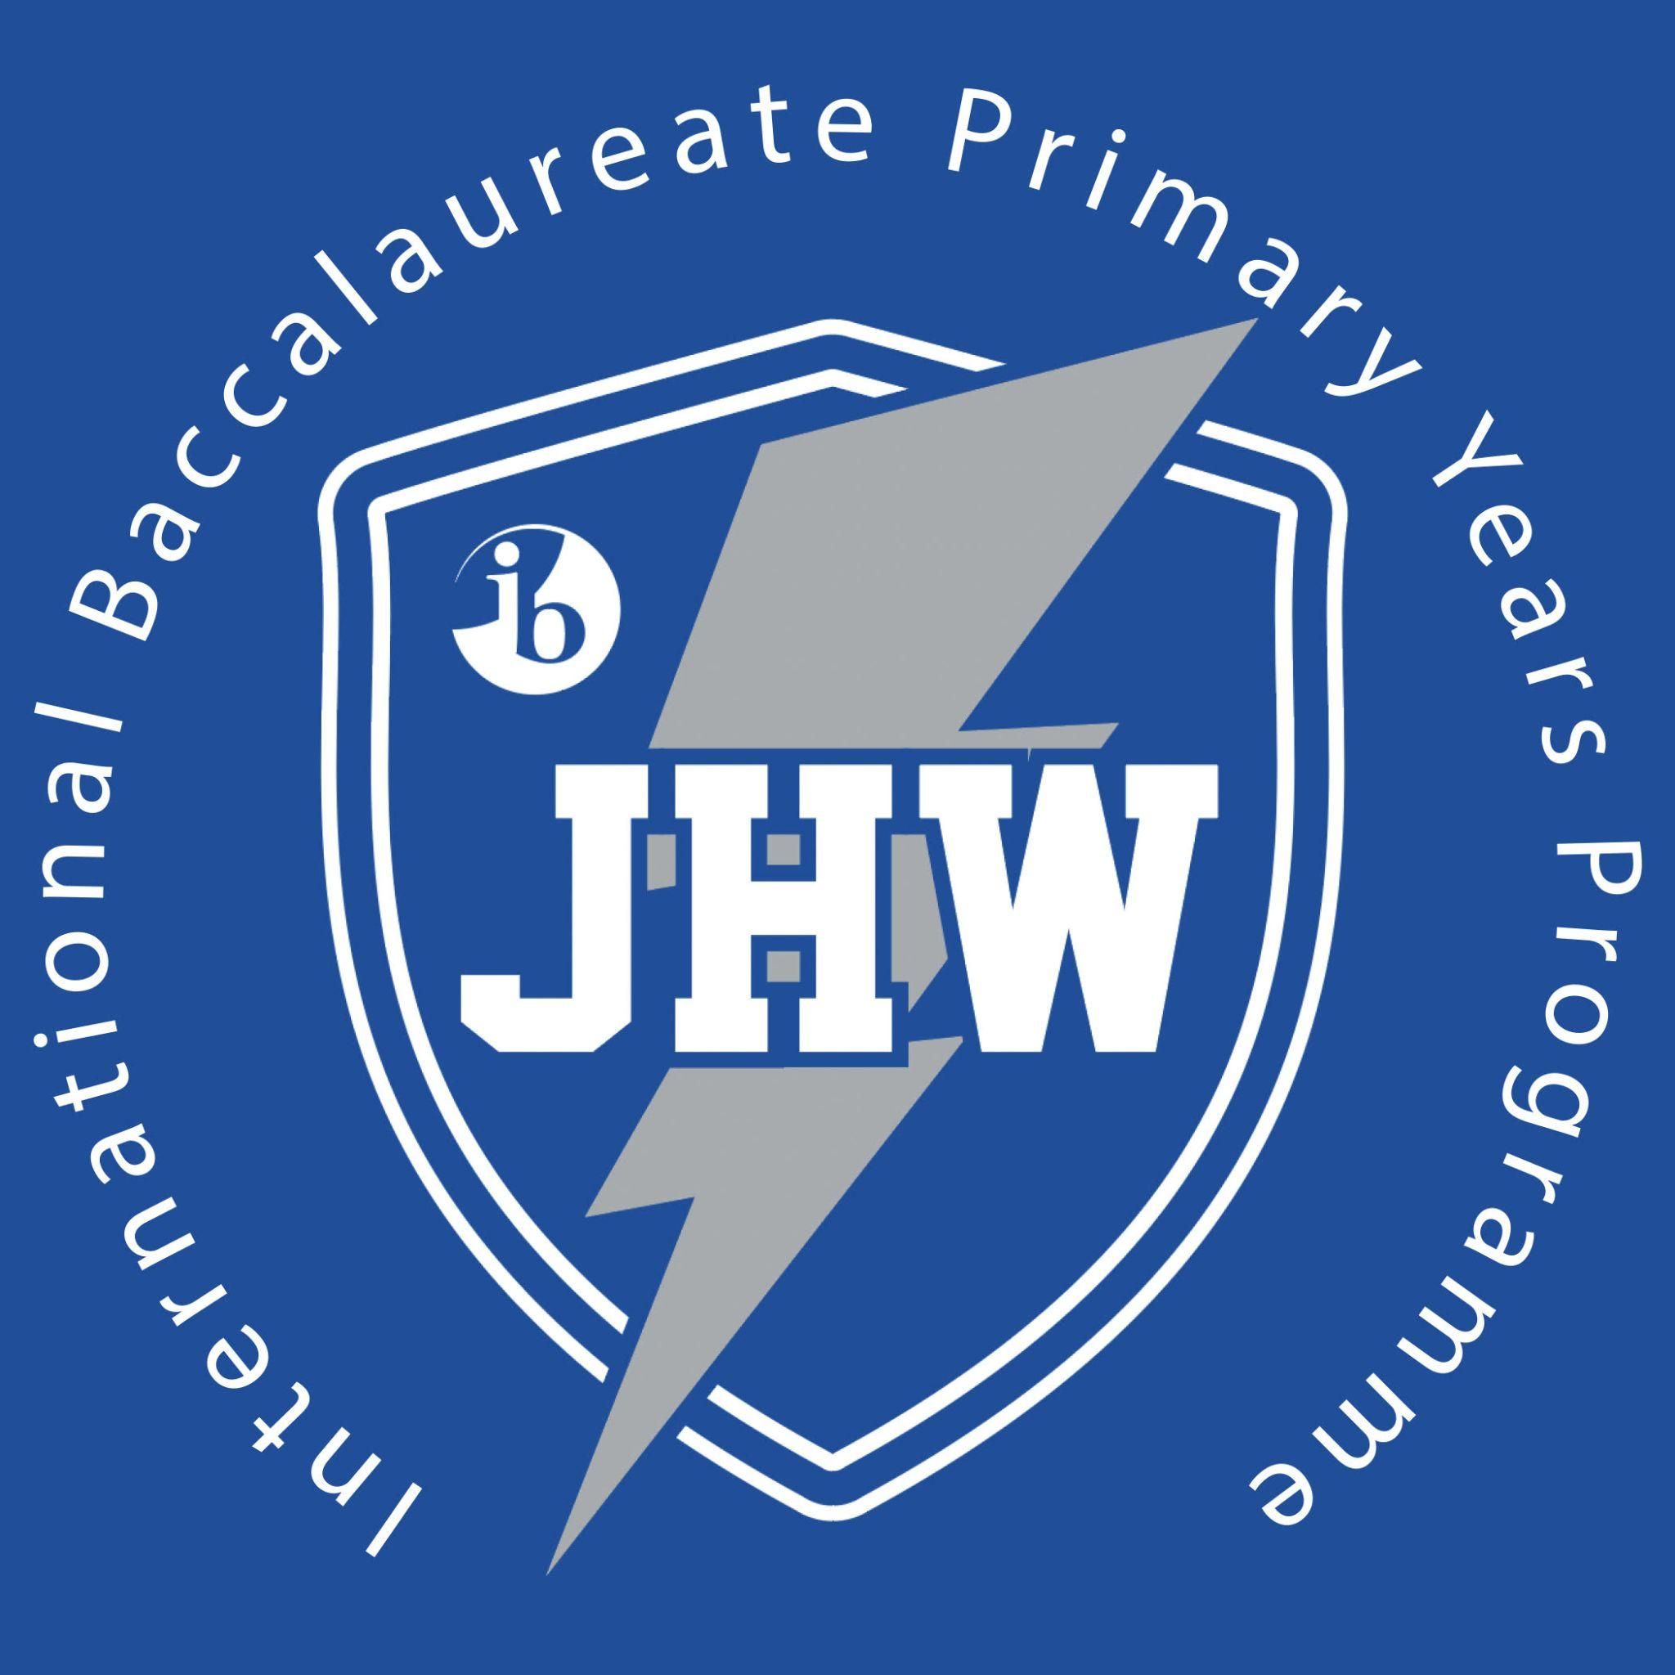

Janie Howard Wilson Elementary
IB PYP Candidate School
306 Florida Avenue, Lake Wales, FL 33853
Phone: 863-678-4211 Fax: 863-678-4217
Kim Griffiths Brittany Alexander
Principal Assistant Principal

NOTICE TO BUILDING OCCUPANTS AND PARENTS
NOTIFICATION OF INSPECTION FOR ASBESTOS CONTAINING

MATERIALS IN PUBLIC SCHOOLS

The Environmental Protection Agency (EPA) has issued a final rule, 40 CFR Part
763, Asbestos Containing Material in schools, commonly referred to as AHERA.
This rule requires all Local Education Agencies (LEA’s) to identify asbestos
containing materials (ACM) in their school buildings and to take appropriate
actions to control release of asbestos fibers.
All inspections for Janie Howard Wilson Elementary have been completed and a
Management Plan describing the results of the inspection and the action plan to
control any asbestos found during the inspection, where applicable, has been
submitted to the Governor for approval. A copy of this plan is located in the
administrative office of this school and at the District School Board of Polk
County Maintenance Department and is available for review upon request.

