**Influenza (Flu)** 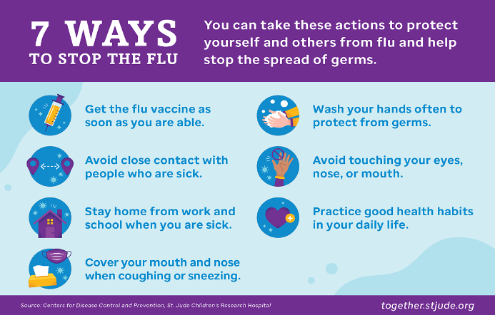

Seasonal influenza (flu) season runs from October through May. The Centers for Disease Control and Prevention (CDC) recommends that everyone six (6) months and older, with rare exceptions, get a flu vaccination every season. Flu vaccines can reduce flu illnesses, hospitalizations, and deaths.

Autauga County Schools partners with Health Hero to provide optional flu vaccine clinics at schools. Contact your school nurse to inquire.

For more information about influenza and the influenza vaccine, visit the Alabama Department of Public Health website: <https://www.alabamapublichealth.gov/flu/>