White Pine County School District
Water Conservation Plan
September 21, 2021

Introduction
Nevada Revised Statute (NRS) 540.011 states that it is the State of Nevada’s policy to recognize the critical nature of the State’s limited water resources. In the spirit of this policy, NRS 540.131 requires water conservation plans to be submitted to the Division of Water Resources which includes the public water system that serves the Lund K-12 school. Each supplier of water that supplies water for municipal, industrial or domestic purposes shall adopt a plan of water conservation based on climate and living conditions of its service area in accordance with NRS 540.141. NRS 540.131 state that the plan must:
Must be available for inspection by members of the public during office hours at the office of the supplier of water
- Must be available for inspection by members of the public during office hours at the offices of the supplier of water;
- May be revised from time to time to reflect the changing needs and conditions of the service area. Each such revision must be made available for inspection by members of the public; and
- Must be updated every 5 years and comply with the requirements of this section and NRS 540.141.

Required provisions of the plan are identified in NRS 540.141 (effective January 1, 2020)

1. A plan or joint plan of water conservation submitted to the Section for review must include provisions relating to:
(a) Methods of public education to:
(1) Increase public awareness of the limited supply of water in this State and the need to conserve water.
(2) Encourage reduction in the size of lawns and encourage the use of plants that are adapted to arid and semiarid climates.
(b) Specific conservation measures required to meet the needs of the service area, including, but not limited to, any conservation measures required by law.
(c) The management of water to identify and reduce water loss in water supplies, inaccuracies in water meters and high pressure in water supplies, which must include, without limitation:
(1) Goals for acceptable levels of water loss in water supplies. Such goals may use the following performance indicators and analyses, without limitation:
(I) Infrastructure water loss index;
(II) Water audit data validity score;
(III) Operational basic apparent losses;
(IV) Operational basic real losses; and
(V) Economic level of water loss.
(2) A plan which analyzes how the supplier of water will progress towards the goals established for the acceptable levels of water loss.
(d) The management of water to, where applicable, increase the reuse of effluent.
(e) A contingency plan for drought conditions that ensures a supply of potable water.
(f) A schedule for carrying out the plan or joint plan.
(g) A plan for how the supplier of water will progress towards the installation of meters on all connections.
(h) Standards for water efficiency for new development.
(i) Tiered rate structures for the pricing of water to promote the conservation of water, including, without limitation, an estimate of the manner in which the tiered rate structure will impact the consumptive use of water.
(j) Watering restrictions based on the time of day and the day of the week.

Lund Public Water System

The Lund K-12 school has a public water system that is used exclusively for the Lund school. Water is pumped from a well into large storage tanks that provides water for domestic use and fire safety. Water is first supplied to a 44,000 fire/irrigation water storage tank and then pumped into at 8,000 potable water storage tank. Approximately 7,500 gallons are required for fire protection and a minimum of 4’ of water is maintained in the tank at all times. Irrigation water usage is approximately 0.2 gallons per square feet per day times 136,490 square feet which is approximately 27,298 gallons per day. Potable water usage is approximately 6+- gallons per day per person. Engineering estimates were based on 234 people which is approximately 1,404 gallons. The required storage capacity is estimated to be 1.75 x 1,404 gallons or 2,457 gallons. Currently there are fewer than 150 students and staff in this facility. The diagrams below provide additional details with respect to the operating design.
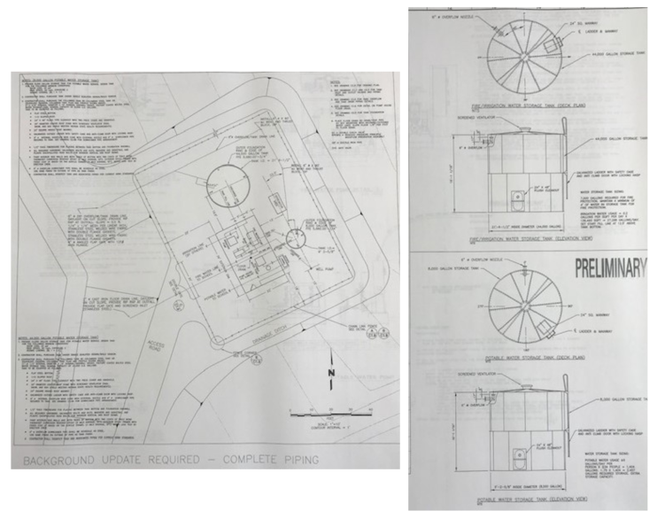

Wastewater is collected in two septic systems. A 10,000 gallon tank serves the main building and a 1,200 gallon tanks serves a separate vocational building. The systems utilize a dosing tank, distribution box and perforated gravity sewer pipe inside leaching chambers that supply leach fields.

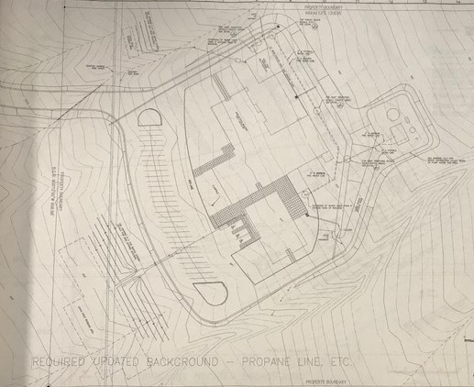

The school was constructed through the State of Nevada Department of Public Works project and was operational in August 2000.

Methods of Public Awareness

The water systems owned by the school district supplies water to the Lund K-12 school which houses approximately 100 to 120 students and staff. NRS 540.141 requires the school district increase public awareness of the limited supply of water in this State and the need to conserve water. It also requires purveyors of public water systems to encourage the reduction of the size of lawns and encourage the use of plants that are adapted to arid and semiarid climates. Because the public water system only serves the Lundk-12 school and does not provide water resources to the community for lawns or other purposes, the method of awareness will focus on education and awareness of Nevada’s limited supply of water.

The communities in White Pine County are keenly aware of the scarcity of resources in Nevada and have been concerned about attempts from Southern Nevada to take ground water from underground basins in White Pine County. If underground water is pumped to Southern Nevada, it is unknown how this withdrawal will affect the underground water resources and the communities that these water resources serve.

The school district will provide the following methods of public education

- Public Input: The District will provide the public with opportunities to provide input on the District’s water conservation plan

- Copies of the Plan Available for Public: Copies of the plan will be made available upon request and will be posted on the school district web-site

- Water Conservation Information: Water conservation information will be made available at the school office.

- Classroom Education: Water conservation and environmental science are part of the K-12 science curriculum. Water and other natural resources are components of the curriculum.

Conservation Measures to be Implemented if Needed or in an Emergency

Because this public water system is the only source of water for the school, the District must take measure to conserve and reserve water. The following conservation measures have been implemented.

- Programmable Water System: The District has a programmable watering system for school grounds. This system is programmed to meet local watering conditions based on available water resources.

- Drought Resistant Plants: Drought resistant plants sparsely populate the grounds and grass areas have been conservatively supplied around the campus.

- Water Efficient Fixtures: Water efficient plumbing fixture have been installed in the school to reduce water waste.

- Landscape Reduction: The District will evaluate the current outside landscape uses of water and identify areas that can be modified to reduce water consumption. This is ongoing and will be addressed as funding is available.

- Water Overspray, Repairs & Maintenance: School district personnel are responsible for monitoring landscape water uses and repair broken sprinkler heads and broken or leaking lines. They also adjust sprinkler heads that create overspray.

- Internal Water Usage and Plumbing: The interior water supply is monitored by custodial and maintenance staff. Leaky fixtures are replaced as soon as possible and water efficient fixture have been installed throughout the facility.

- Emergencies: This system is the only system that supplies water to the school so the system is continually monitored and water is tested on a consistent basis. In the event of an emergency, the use of water for exterior purposes would be restricted or eliminated depending on the severity of the emergency. The water for the system is pumped from a nearby well. There is no redundant solution at this time. If the water supply became threatened, the District would have to consider closing the facility on a temporary basis until adequate water could be restored. Students could be transported to schools in Ely or provided distance education opportunities through other community centers or from home.

Management of Water to Identify and Reduce Water Loss

Pursuant to NRS 540.141(c)(1), the water loss goal is zero so the District aspires to accomplish this goal with existing staff and limited resources. The District lacks the financial ability to implement water monitoring infrastructure so water loss is identified by manual inspection. Water systems are inspected on a continual basis by personnel. Outdoor watering is seasonal and system inspections are preformed when the exterior water is turned on and operational. Staff is able to observe the watering system during their regular work day so broken heads, pipes or overspray ban can be monitored by maintenance and custodial staff via observation on a daily basis. An automated work order system is in place that allows ALL staff to enter work orders. The work orders are reviewed by maintenance personnel and custodial staff. Repairs involving water resources are a top priority not only for conservation but also because of the internal damage that can be caused to facilities. Negligent water repairs can be costly so the school district personnel address these issues as soon as possible.

Potable water tanks are visually inspected at least annually by maintenance personnel and the water tank for fire safety/irrigation is inspected annually by certified fire safety personnel. In addition, services to the school are shut off briefly to identify leaks.

The school district does not reclaim water nor does it have the means to do so. This would require significant capital expenditure that would include the acquisition of additional property from the neighboring property owners. Because this is not an option at this time, the district has focused on managing the use of its primary water supply.

Contingency Plan for Drought

As indicated previously, the public water system is the only water system serving the Lund K-12 school. In the event water becomes scarce, water usage would be curtailed in the following priorities:

- Reduce or eliminated exterior watering
- Provide bottled drinking water for consumption as long a sufficient water is available for essential plumbing
- If water is not available for consumption and plumbing, students and staff would have to be temporarily relocated and the school vacated.

In the event the school is vacated, the District would consider using alternative locations within the community, transport students to Ely and/or provide distance education opportunities.

Schedule for Carrying out the Plan

Many of the measures identified in this plan are already in place and part of operating protocol. Resources with respect to water conservation and other conservation measure will be made available at our school district main office upon approval of this plan.

In the event of drought or emergency conditions, the District will adopt the following plan of action:

- Directly notify the school administration of the nature and extent of the drought or emergency
- Implement restrictions
- Follow-up communication via email with further details
- Post a notice in the main entrance of the school
- Post a notification to the school and school district web-site
- Post a notification at the community facilities where the public meeting agendas are posted (if necessary)
- Publish a notification in the local newspaper (if necessary)

The posting requirements will be determined by the Superintendent on a case-by-case basis depending on the severity of the issue.

Plan for Installation of Meters on all Connections

The water system only serves the Lund K-12. There are no other connections.

Standards for water efficiency for new development

The water system only serves the Lund K-12. There are no plans for new development or expansion.

Tiered Rate Structures for the Pricing of Water

The water system only serves the Lund K-12. There are no structures for pricing.

Watering Restrictions

Exterior watering is seasonal and restricted from the hours of 10:00 am through 6:00 pm daily. Watering systems are limited to once daily either in the morning or in the evening. If water resources diminish, water schedules are reduced to every other day. Further restrictions are implemented depending on severity. Stations are limited to 20 minutes per station.

For more information about the Lund K-12 public water system, please contact:

Paul Johnson, Chief Financial Officer
White Pine County School District
1135 Avenue C
Ely, Nevada 89301
(775) 289-4851 x7107 (Office)
(775) 293-0569 (cell)
Paul.johnson@wpcnvadmin.com

