Grant Union Prospectors
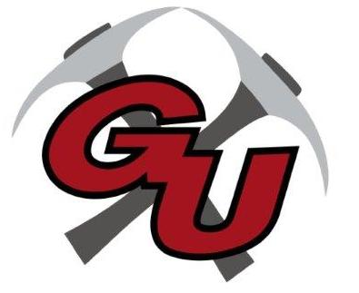
Junior High Wrestling 2023

DATE OPPONENT/SITE TIME DISMISS DEPART
1/17 LaGrande 4:00 12:30 12:45
1/20 Grant Union Tournament (HS/JH) 12:00
1/24 Pendleton (Sunridge) 4:00 12:30 12:45
1/25 Burns/Crane/GU Duals (Burns) 5:00 1:45 2:00
2/3 Pine Eagle Tournament 10:00 6:00am
2/14 Pendleton (Sunridge) 4:00 12:30 12:45
2/21 Grant Union JH Tournament 4:00 3:00
3/4 Regionals (Boardman) TBA
3/11 Middle School State (Woodburn) TBA

Head Coach:
Assist. Coaches:
Athletic Director: Andy Lusco
Principal: Karen Shelton
Superintendent: Louis Dix

