SCHOOL BUS DRIVERS NEEDED
Williamsburg County School District Annex
500 North Academy Street Building A, Kingstree, SC 29556
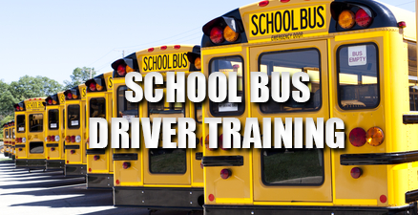
Starting Salary $14.74/hr. (zero experience)
$2,000 Hiring Bonus (First Time New Drivers to the District)
**With Stipulations**
DATE: Contact Transportation Department for training class dates.

The following documents are required prior to attending the training:
- Copy of current drivers record

To receive credit, you must attend all four sessions and be on time each day. No exceptions.

For additional information, please contact the following:
Dr. Brian McKnight – (843) 355-0882 ext. 6192 – Director of Transportation
Andrea June – (843) 355-0882 ext. 6193 – Kingstree Area & Greeleyville Area
Rontrecia Hannah Platt – (843) 558- 9413 ext. 3300 – Hemingway Area

