SENIOR MASTER SERGEANT (RET) TALBERT R. KNEPSHIELD
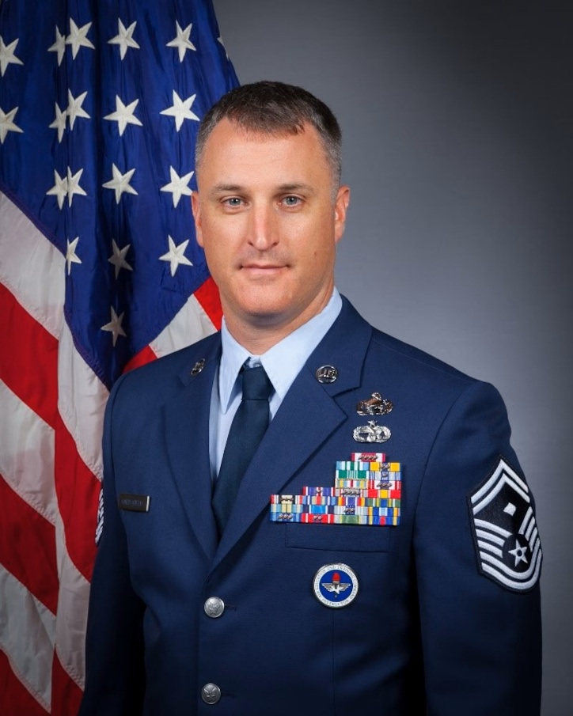
Senior Master Sergeant (Ret.) Talbert Knepshield proudly served more than 20 years in the United States Air Force, culminating his career as a senior enlisted leader responsible for the development, readiness, and welfare of hundreds of Airmen. Throughout his service, he held leadership positions spanning intelligence operations, logistics, personnel management, and executive-level advising.

During his career, Mr. Knepshield served as a First Sergeant, First Sergeant Instructor, Senior Enlisted Leader, and Commanders’ Professional Development School Instructor. He led organizations of up to 550 personnel and was responsible for the readiness and professional development of military members serving around the globe. As an instructor, he trained and mentored future military leaders, including senior officers selected for command, while developing programs that continue to support Airmen across the Air Force.

His operational experience includes supporting intelligence missions, managing large-scale personnel and logistics operations, and overseeing the movement and readiness of hundreds of personnel and aircraft during major joint and coalition exercises. He also deployed in support of operations in the Middle East, where he served in key leadership and force protection roles during combat and contingency operations.

Mr. Knepshield holds a Master’s Degree in Organizational Management, is a Lean Six Sigma Black Belt, Executive Coach, Master Resiliency Trainer, and recipient of six Meritorious Service Medals, the Joint Service Commendation Medal, and multiple service and achievement awards. Throughout his career, he became known for developing leaders, improving organizational performance, and fostering high-performing teams in complex and demanding environments.

His military service was defined by a commitment to leadership, mentorship, and mission accomplishment—values he continues to carry forward in service to his community and future generations.

EDUCATION
2010 Airman Leadership School, Vandenberg Air Force Base (AFB), Calif.
2010 Associate Degree Transportation Management, Community College of the Air Force (CCAF), Maxwell-Gunter AFB, Ala.
2015 Associate’s Degree in Intelligence Analysis, CCAF, Maxwell-Gunter AFB, Ala.
2015 Senior Enlisted Joint Professional Military Education I course, by correspondence
2016 Master Resiliency Trainer Course, Joint Base (JB) McQuire-Dix-Lakehurst, N.J.
2016 Noncommissioned Officer Academy, CCAF, Maxwell-Gunter AFB, ala. by correspondence
2017 Noncommissioned Officer Academy, Tyndall AFB, Fla.
2018 Senior Noncommissioned Officer Course, by correspondence
2018 Senior Enlisted Joint PME II Course, by correspondence
2018 Professional Managers Certification, CCAF, Maxwell-Gunter AFB, Ala. by correspondence
2018 Bachelor of General Studies, American Military University (AMU), Charles Town, W.Va.
2022 Human Capital Leadership Certificate, AMU, Charles Town, W.Va.
2022 Master of Arts, Organizational Management, AMU, Charles Town, W.Va.
2025 Leadership Agility Certificate, Cornell University, Ithaca, NY

ASSIGNMENTS
1. February 2006–April 2006, student, vehicle operations apprentice, 366th training squadron, Fort Leonard Wood, Mo.
2. May 2006–January 2011, NCOIC, Vehicle Operations Control Center, 30th Logistics Readiness Squadron, Vandenberg AFB, Calif.
3. January 2011–January 2012, Vehicle Operator Dispatcher, 51st Logistics Readiness Squadron, Osan Air Base (AB), Republic of Korea (ROK)
4. January 2012-October 2012, Vehicle Operator Dispatcher, 633rd Logistics Readiness Squadron, JB Langley-Eustis (JBLE), Va.
5. October 2012-August 2013, Wing Recognition Monitor, 633rd Air Base Wing, JBLE, va.
6. August 2013-November 2015, Dispatcher, 633rd Logistics Readiness Squadron, JBLE, Va.
7. November 2015-January 2018, Section Chief, Combat Targeting, 36th Intelligence Squadron, JBLE, Va.
8. January 2018–January 2019, Flight Chief, Imagery Operations, 6th Intelligence Squadron, Osan AB, ROK
9. February 2019-March 2020, First Sergeant, 48th Intelligence Squadron, Beale AFB, Calif
10. April 2020-June 2021, First Sergeant, 9th Aircraft Maintenance Squadron, Beale, AFB, Calif
11. July 2021-June 2022, First Sergeant, 51st Aircraft Maintenance Squadron, Osan AB, ROK
12. July 2022-July 2023, First Sergeant, 96th Aircraft maintenance Squadron, Osan AB, ROK
13. August 2023-August 2024, Instructor, First Sergeant Academy, Maxwell-Gunter AFB, Ala.
14. August 2024-January 2026, Instructor, Commanders’ Professional Development School, Maxwell AFB, Ala.

MAJOR AWARDS AND DECORATIONS
Meritorious Service Medal with six oak leaf cluster
Joint Service Commendation Medal
Air Force Commendation Medal two oak leaf cluster
Army Commendation Medal
Air Force Achievement Medal with oak leaf cluster

OTHER ACHIEVEMENTS
2007 Vehicle Operator of the Year, Air Force Space Command
2016 Noncommissioned Officer of the Year, 36th Intelligence Squadron
2017 Distinguished Graduate, Commandant Award Winner, Airey Noncommissioned Officer Academy
2018 SNCO of the Year, 6th intelligence squadron

EFFECTIVE DATE OF PROMOTION
Airman Basic Jan. 3, 2006
Airman First Class Feb. 17, 2006
Senior Airman June 17, 2008
Staff Sergeant June 1, 2010
Technical Sergeant May 1, 2016
Master Sergeant June 1, 2018
Senior Master Sergeant June 1, 2020

(Current as of August 2026)

