|  |  |
| --- | --- |
| You can’t build a Chimney from the Top  Dr. Joseph Winthrop Holley | 2025 SCHoLaRSHIP PACKAGE  Albany State University  National Alumni Association  Warner Robins Area Chapter  **Post Office Box 1253**  **Warner Robins, Georgia 31099**  **wracasunaa@gmail.com**  Gladys Bryant  Chairperson |

Contents

Warner Robins Area Chapter, Albany State University National Alumni Association 2

2025 ASU Scholarship 2

*Student Letter* 3

*Scholarship Application Form* 4

*Selection Criteria* 5

Albany State University (ASU)

National Alumni Association

Warner Robins Area Chapter

**Post Office Box 1253**

**Warner Robins, Georgia 31099**

Warner Robins Area Chapter, Albany State University National Alumni Association

*presents*

2025 ASU Scholarship

This is an opportunity for 2025 graduating seniors from Houston County and Peach County high schools to compete for one or more scholarships in the amount of $1000 for post-secondary education at Albany State University. The recipient will receive this award at the school’s annual Senior Honors Day, or an appropriate ceremony held by the local alumni chapter.

Final application submission date: Monday, March 31, 2025.

We encourage graduating seniors to contact your high school counselors to obtain an application package and receive mailing instructions or send a request for an application package to the email address listed below.

Our chapter’s 3-fold purpose in awarding this scholarship is to: (1) recognize graduating seniors for outstanding achievement, (2) provide assistance for continuance of exemplary schoolwork beyond secondary school, and (3) enhance interest in enrollment for further study at Albany State University.

Thanks to a future ASU Ram for your participation in the 2025 scholarship competition.



POTENTIAL. REALIZED.

Gladys Bryant, Chair

WR Area Chapter ASU National Alumni, Scholarship Committee

e-mail: wracasunaa@gmail.com

# *Student Letter*

The Warner Robins Area Chapter of the Albany State University National Alumni Association will award one or more scholarships in the amount of $1000 to 2025 graduating seniors from Houston and Peach County high schools. We will present the scholarships to award winners at your high school’s Senior Honors Day program, or an appropriate ceremony held by our local alumni chapter. We encourage you to submit an application to compete for one of these scholarships. Student applications will be judged and evaluated against the scholarship criteria provided on the attached forms.

Our chapter’s 3-fold purpose in awarding these scholarships is to: (1) recognize graduating seniors for outstanding achievement, (2) provide assistance for continuance of exemplary schoolwork beyond secondary school, and (3) enhance interest in enrollment for further study at Albany State University.

We encourage you to compete for this recognition and financial assistance.

Please email your completed application to the undersigned at wracasunaa@gmail.com by Monday, March 31, 2025. Completed packages can also be mailed, post marked not later than March 31, 2025, to:

Ms. Gladys Bryant

ASUNAA WRAC

POB 1253

Warner Robins, GA 31099-1253

Thanks to a future ASU Ram for your participation in the 2025 scholarship competition.

Sincerely,

Gladys Bryant

Scholarship Committee Chairperson

Warner Robins Area Chapter

Albany State University National Alumni Association

Atch: Application w/Forms

# *Scholarship Application Form*

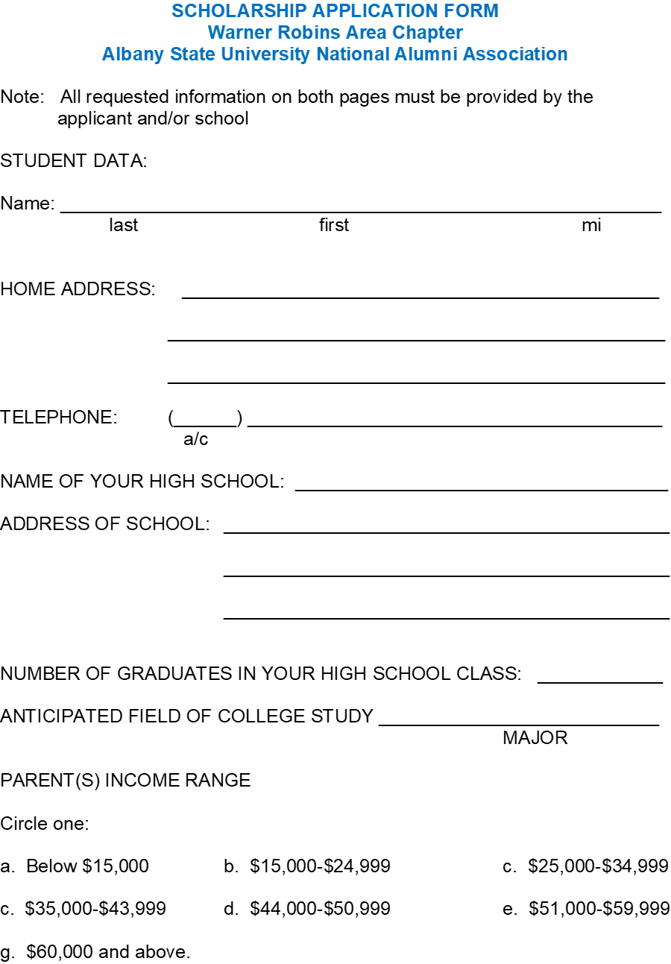

# *Selection Criteria*

**SCHOLASTIC ACHIEVEMENT**

GPA ________ of maximum ________

Class standing ________ of ________

**SAT/ACT test scores**

Verbal **________**

Math **________**

Written **________**

Combined ________

**EXTRACURRICULAR ACTIVITIES**

_______________________________________________________________________________________________________________________________________________________________________________________

**AWARDS/HONORS**

________________________________________________________________________________________________________________________________________________________________________________________________________________________

**FINANCIAL NEED**

_______________________________________________________________________________________________________________________________________________________________________________________

**ESSAY**

Write an essay explaining (1) why you would like to receive the scholarship, (2) what economic

need/benefit the scholarship would meet, and (3) what you as a unique and talented individual

can offer the institution.

**LETTERS OF RECOMMENDATIONS (2)**

(NOTE: Letters cannot come from family members)

**DEADLINE**

The completed application must be **postmarked** no later than Monday, March 31, 2025 if mailed.