**JMJ**

**Saint Patrick Catholic Church**

**301 Shamrock Trail**

**Adamsville, Alabama 35005**

**205-798-5326**

**Very Rev. Anthony Weis, Pastor**

**Volume 40 July 30, 2023 Number 31**

**Seventeenth Sunday in Ordinary Time**

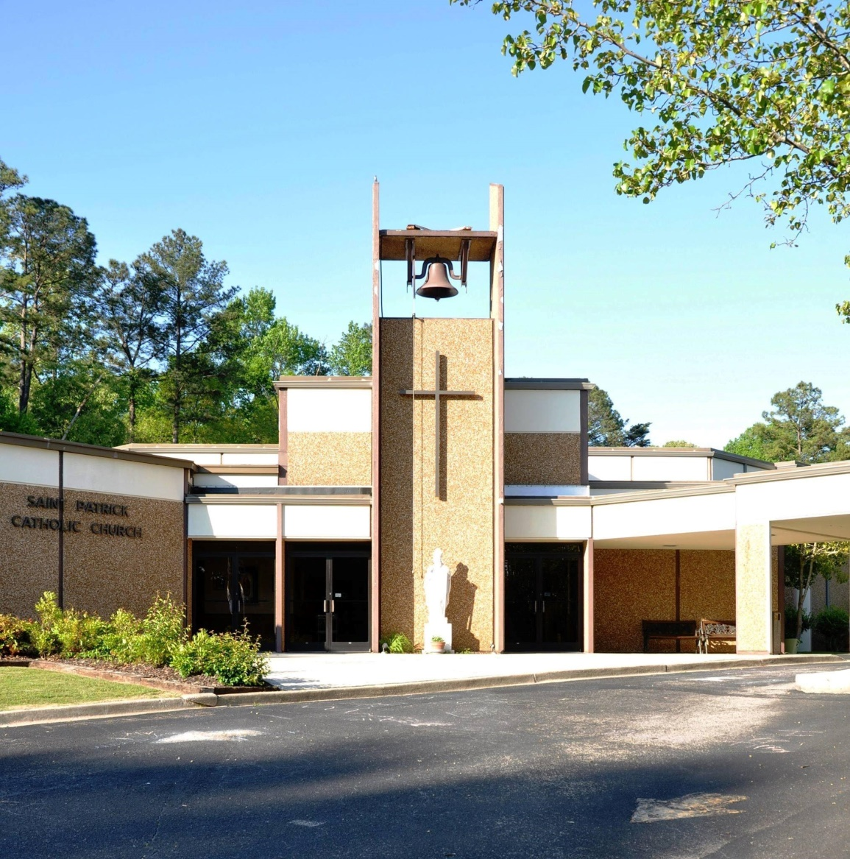

**Celebration of the Holy Sacrifice of the Mass**

*Saturday, 4:00 pm ❖ Sunday, 10:00 am (English) 12:00 Noon (Spanish)*

Wednesday and Thursday, 9:00 am

First Friday, 10:00 am

Holy Days of Obligation, Vigil 6:30 pm (Bi-Lingual), 10:00 am

**The Sacrament of Reconciliation**

One hour before each Mass or by appointment



***PLEASE PRAY***

**PRAY FOR OUR PARISHIONERS IN THE HOSPITAL OR ON HOSPICE:** Please keep all the sick and their caregivers in your prayers.

**PRAY FOR OUR PARISHIONERS WHO ARE UNABLE TO LEAVE THEIR HOMES** Betty Carroll, Mickey Davidson and Linda Karch, Paul Vizzinia. Please keep these, all the homebound, and their caregivers in your prayers. If you know of any parishioner who should be added to or removed from this list, please contact the office.

**PRAYER BOOK:** The prayer book in the narthex is available for all prayer requests. Please pray daily for these requests.

**PRAY FOR OUR TROOPS:** Especially our families, friends and loved ones who are currently in active military service: Joseph Byrd (Stateside), Bret King (Stateside), Jason King (Stateside) Please keep all of our brave men and women in your prayers. **Please call the office to add to or remove names from this list.**

***PARISH ORGANIZATIONS***



**SHAWL MINISTRY:** We will meet the second Monday of every month. For more information contact Mary Evans.

**Knights of Columbus Charity Banquet tickets are available**! The Charity Banquet will be held on Saturday, August 12th from 6-10pm at Barn at the Bend in Hayden, AL. Tickets are $100 & admit 2 people, and this will include a chance at the prize money, dinner, & drinks. Contact James Nelson or any other Knight for more information & to buy a ticket.

**Knights of Columbus Council 10567** will meet Thursday, August 3 at 7 p.m. in the Charles L. Blanchard Knights of Columbus room. Mass is at 6 p.m. in the Chapel and food will be served after Mass. All Knights are urged to attend.

**SUMMER BINGO:**   Come and enjoy some delicious hot dogs with all the fixins, a drink, chips, and a dessert for only $5.00 this Saturday, July 29th in St. Joseph's hall. The games will begin after the 4:00 pm Mass. Bring some friends, win some money, and enjoy Door Prizes, as well as, try your luck at the 50/50 drawing! It is only 25 cents for a Bingo card so play as many as you want. It will be a family fun-night-out for all. Hope to see you there!

**THE LADIES AUXILIARY** of the Knights of Columbus will have their installation of officers for this year on Thursday, August 3 at 6:30 pm in St. Joseph hall. Installation will be followed by dinner. If you are interested in becoming a member of the auxiliary, we invite you to join us at this meeting as we begin our 25th year !

**RCIA** Considering joining the Catholic Church or know someone who may be interested? Catholic but never confirmed? Need to make your First Communion? Want to be baptized? Let us help you! Check out our RCIA classes for adults considering joining the Catholic Church. Come and Learn. For more information, please call the church office. Weekly classes on Tuesday Sept.– April.

**OTHER ITEMS OF NOTE**

**LAWN AND LANDSCAPE** We are always looking for help to maintain the lawn and landscape at St. Patrick. We work every other Thursday from 7am till 11am.Here are the dates for the summer (weather permitting Aug 3rd, Aug 17th, Aug 31st, Sept 14th and Sept 28th. Contact Dale Blanchard at 205-541-6597

**CATHOLIC CHARITIES UPDATE** Our Parish goal is 20,000.00 46 people have pledged a total of 13,895.00. Please prayerfully consider giving to Catholic Charities to help us reach our goal.

**CLEAN OUT FOR CHRIST IS COMING** It’s that time of the year to start working on donations for our annual yard sale. We are accepting donations thru Sunday, September 17, 2023. Items to donate are toys, children’s clothes and shoes, baby items, home decor, kitchen items, adult shoes, handbags, jewelry, furniture, tools, sporting equipment, linens, books, CDs, DVDs, and records. Items that we cannot accept are mattresses, box springs, pianos, organs, ping pong tables, box TV’s, car seats, cribs, and adult clothing. We ask that all donations are clean and in working order. Tables will be marked in the back of St. Joseph’s Hall for donations to be placed. Please contact Margaret Pender at M.pender@ymail.com if you have furniture items to donate or any questions about this sale. Thank you for your support of this event! Dates for the sale will be announced at a later date.

**WEDDING VOW RENEWAL:** Fr. Weis has graciously agreed to perform Marriage Renewals on Sunday August 13, 2023 at the 10 am Mass. These are traditionally done for anniversaries ending in a zero or five. For Example; 20th or 35th. Other anniversary dates are welcome. If interested, call Sara Jean Brooklere at 205-903-4080 or Anthony Brooklere at 205-903-5080

**Weekly Mass Schedule**

|  |  |  |  |  |
| --- | --- | --- | --- | --- |
| Seminarian Education Fund | Saturday | 07/29 | 4:00pm | Todd Bolton - H |
|  | Sunday | 07/30 | 10:00am | For the People |
|  | Sunday | 07/30 | 12 Noon (Spanish) | Hector Carrillo - ✝ |
|  | Monday | 07/31 | No Mass |  |
|  | Tuesday | 08/01 | 9:00am @ St. Stanislaus |  |
|  | Wednesday | 08/02 | 9:00am | Dorothy Reyes - ✝ |
|  | Thursday | 08/03 | 9:00am | Pat Rogato - ✝ |
|  | Friday | 08/04 | 9:00am @ St. Stanislaus |  |
| Capital Improvements | Saturday | 08/05 | 4:00pm | Henry H. Bailey Family - SI |
|  | Sunday | 08/06 | 10:00am | Mary Ann Tudisco - ✝ |
|  | Sunday | 08/06 | 12 Noon (Spanish) | For the People |

**VISITS TO THE SICK** If you are ill and in need of the Sacraments and would like a visit from Fr. Weis, he has asked that you (or an immediate family member if you are too ill) contact him through the church office or at 205-546-9309. The surest way of getting the message to Father is by speaking to him personally during office hours or calling the church office and leaving a message either on the answering machine or with a member of the office staff.

**PLEASE JOIN OUR PARISH!** We would love to have you. Please pick up a Census Card in the narthex. Place completed card in the collection basket

\

**Next Week’s Readings**

**1st Reading:** (Daniel 7:9-10,13-14) **2nd Reading**  ( 2 Peter 1:16-19)  **Gospel**  (Matthew 17:1-9)

**Sixteenth Sunday in ordinary time:** God invites us to ask for what we need. Consider what Solomon requested- an understanding heart. What do you need as you seek to follow Jesus?(1 Kings 3:5,7-12) Let us pray for the world and Church leaders, may they work for the reign of God with an understanding heart. **(Vocation View is sponsored by Serra Club)**

**AROUND THE DIOCESE**

**22nd National Conference for all single Catholics** August 25th-27th, 2023 - Join 400+ singles coming from all parts of the US at the 22nd National Conference for Single Catholics at St. John’s Resort, in Plymouth, MI OR participate virtually and engage with others via the online socials and small group discussions.This is your chance to connect with like-minded singles (of all ages). The weekend includes talks by dynamic speakers, music, social events, Mass, adoration, fellowship and more. (If joining us in-person, use the promo code (**PARISH23**) when you register to get $50 off! Discount for the first 50 sign ups nationwide to use this code.) Visit [NationalCatholicSingles.com](https://nationalcatholicsinglesconference.msnd26.com/tracking/lc/4e1dfc94-14e0-4018-ab48-f9d3f0cd6771/032b30e6-7d8f-4305-b87f-b0b0d5009e24/58fb9e22-6b95-4d72-9607-f0ef8d253b65/) for more information and to register.

**[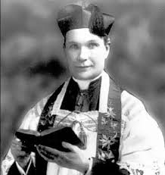](http://www.google.com/imgres?imgurl=http://media.al.com/spotnews/photo/rev-james-coyle-jpg-41d2433b930c3548.jpg&imgrefurl=http://blog.al.com/spotnews/2012/02/priests_slaying_in_birmingham.html&h=442&w=416&tbnid=LKlCtZjnpuZRHM:&zoom=1&docid=1cPJ8GgY_ymKAM&ei=ZXmJVbj4PImvyASXpZqQDA&tbm=isch&ved=0CCQQMygHMAc)**

**Let’s Remember a Priest Killed in the Line of Duty.** The Annual Father James E. Coyle Memorial Mass with Celebrant, Most Reverend Thomas J. Rodi, D.D. Archbishop of Mobile is on Friday, August 11, 2023 at 10:00 A.M.: Reception and Reflections on Father Coyle: Cathedral of St. Paul · 2120 3rd Ave. North, Birmingham: 205.447.8796 · [www.fathercoyle.org](http://www.fathercoyle.org) *"Father Coyle was a martyr to duty"* *The Rt. Rev. Edward Allen, Bishop of Mobile – 8/12/192*

**THEOLOGY ON TAP** is the second Tuesday of every month at Vecchia Pizzeria. The event starts at 6:30 and the talk starts at 7:00pm. **Address for Vecchia: 610 Preserve Pkwy Suite 100 Hoover, AL 35226**

**ST. VINCENT DE PAUL**

**MEETING:** Our next meeting will be held on Sunday, August 6th after Mass.

In the Gospel, we find that the demand of daily Christian living is to spend our life primarily searching for the kingdom of God. This month through your gifts, the Society of St. Vincent de Paul was able to assist 6 families with groceries, and 4 families with payments for utilities, rent, etc. for a total amount of $1,337.00. Thank you for your generosity! **Sixteenth Sunday in Ordinary Time:** Hearing this Gospel, we will mercifully gather us into his kingdom. **This week, please say a special prayer each day for the poor and forgotten in our parish.**

**We are out of these items**

Mac and cheese Ketchup

Mayonnaise

Sugar 2# or 4#

Flour 2# or 4#

Cornmeal 2# or 4#

Canned Greens

Yams





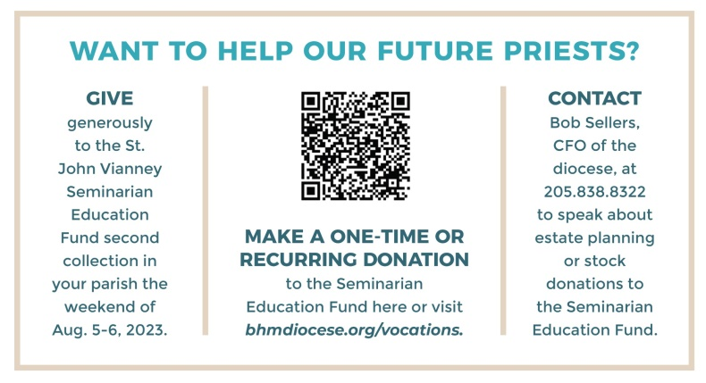

**St. Patrick will collect for this Appeal this Weekend – July 29th & 30th**