2022/2023 School Year
2ND Grade School Supply List
- Headphones for classroom iPads (no $1 ones they break within a week)
- 1 pencil box/bag
- 2 plastic folders
- 2 boxes of Crayola Crayons, 24 count
- 1 bottles of Elmer’s glue (4 oz.)
- 2 packages #2 pencils
- 1 pair of blunt school scissors
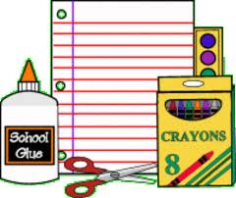
- 6 glue sticks
- 1 set of Expo-Dry erase markers
- 2 composition notebooks
- 1” Three ring binder with dividers
- 2 containers of Clorox wipes
- 2 bottles of hand sanitizer (8 oz. or greater)
- Pack of Post it notes
- 1 box of quart sized Ziploc bags
- 1 box of quart sized Ziploc bags
- 2 boxes of facial tissue
- 1 package of multi-colored construction paper
- 1 package of white copy paper
- 1 pack of colored copy paper
- 1 pack of colored card stock

