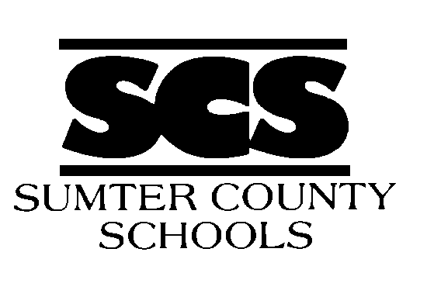 SUMTER COUNTY BOARD OF EDUCATION

REGULAR MEETINGS CALENDAR

JANUARY 2024 – JANUARY 2025

WORK SESSION BOARD MEETING

JANUARY 8, 2024 JANUARY 11, 2024

FEBRUARY 12, 2024 FEBRUARY 15, 2024

MARCH 11, 2024 MARCH 14, 2024

APRIL 9, 2024 APRIL 11, 2024

MAY 6, 2024 MAY 9, 2024

JUNE 17, 2024 JUNE 20, 2024

JULY 8, 2024 JULY 11, 2024

AUGUST 5, 2024 AUGUST 8, 2024

SEPTEMBER 9, 2024 SEPTEMBER 12, 2024

OCTOBER 7, 2024 OCTOBER 10, 2024

NOVEMBER 11, 2024 NOVEMBER 14, 2024

DECEMBER 3, 2024 DECEMBER 5, 2024

JANUARY 7, 2025 JANUARY 9, 2025

Please Note: Work sessions begin at 6:00 P.M. Regular meetings begin at 7:00 P.M. All meetings will be held in the board room at the SCS Administration Building, 100 Learning Lane, Americus, Georgia 31719.

SUMTER COUNTY BOARD OF EDUCATION – 100 LEARNING LANE – AMERICUS, GEORGIA 31719 – 229-931-8500
The Sumter County School System does not discriminate on the basis of race, color, national origin, sex, age or handicap in any educational program/activities or in employment practices.

