

**Second Grade Units of Study**

Engineering Design Process (Science and Engineering Practices)

Computer Science - Flow Based Coding with SAM Labs Technology

Science Process Skills

Erosion

Pet Robots - Read an Instructional Manual

Seed Dispersal & Pollination

Engineering - Build a Treehouse

Mrs. Penny Buckley

pbuckley@dd4.k12.sc.us

STEM Lab Instructor

STEM Expectations

*Be Respectful - follow directions, listen to all ideas, be kind

*Be Responsible - follow classroom routines, use self-control, stay on task,

use materials appropriately

*Be Ready to Learn - stay on task, try your best, stay positive

Don’t Give Up!

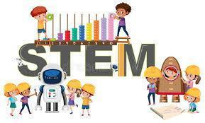

**Grading**

STEM activities will receive a grade based on participation during STEM Lab. It will supplement science; therefore, grades will be integrated with the homeroom science grade.



Wish List

*Craft Sticks *Pompoms

*Wiggly Eyes *Play-Doh

*Pipe Cleaners *Paper Plates

*Paper Lunch Bags *Cotton Balls

*Hot Glue Sticks *Paper Towels

Recycled Materials

*Cardboard Tubes

*Empty Tissue Boxes

*Clean, Empty Egg Cartons

*Scraps of Cardboard