**Systems Information Technology**

**Dual Enrollment Pathway**

**PICKENS COUNTY COLLEGE & CAREER CENTER**

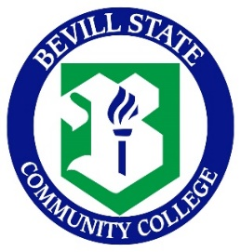 

**FALL SPRING**

**10th Grade 10th Grade**

CIS 150 – M-W-F CIS 251- M-W-F

CIS 157 – T-TH CIS 220- T-TH

HIS201 – United States History I HIS201 – United States History I

PSY200 – General Psychology Humanities (Art/Music/Spanish)

**Summer**

CIS 134/CIS 286 – M-W

**11TH Grade 11TH Grade**

CIS 207 – M-W-F CIS 161 – M-W-F

CIS 227 – T-TH CIS 245 – T-TH

ENG101 - English Composition ENG102 - English Composition

BIO103 – Principles of Biology SPH107 – Fundamentals of Public Speaking

**Summer**

CIS 146/CIS 147 – T-TH

Su

ENG **12th Grade 12th Grade**

CIS 182/CIS 199 – M-W-F CIS 268/CIS 269 – M-W-F

CIS 246 – T-TH CIS 282 – T-TH

MTH100 – Intermediate College Algebra MTH112 – Precalculus Algebra

**OR**

MTH 116 16

**Believe. Achieve. Succeed.**

**Bevill State Community College**

It is the policy of the Alabama Community College System, its Board of Trustees, and Bevill State Community College, a postsecondary institution under its control, that no person shall be discriminated against on the basis of any impermissible criterion or characteristic, including, but not limited to, race, color, national origin, religion, marital status, disability, gender, age, or any other protected class as defined by federal and state law.