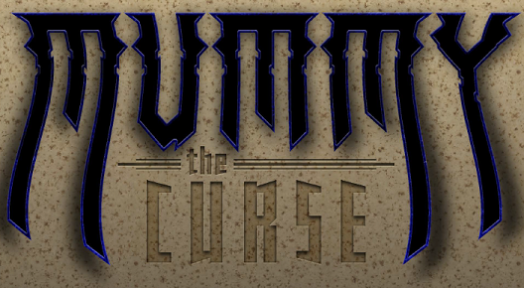

**Reading News**

**Mrs. Williams**

**Date: April 14, 2025**

**Story:** The Mystery of the Mummies Curse

**Word Study:**

-other Bossy R combinations

**Vocabulary:**

**exhibit –** a display

**grimace –** to look like you are in pain

**artifact –** objects that are made, used, or modified by humans and give us information about life in the past

**valuable –** worth a great deal of money

**publicity –** making information public

**overheard conversation** – to hear what others are saying without meaning to

**sensation –** a feeling you get from your senses

**description –** talk or writing that tells you about something

**invitation –** a formal request to go somewhere or do something

**escape –** to get away