Mrs. Bowles’ Newsletter
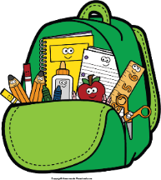
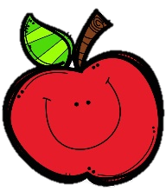
May 2-6, 2022
Grammar (commas) and

Reading Skills (sequencing) Tests: Thursday
Spelling (suffixes -less, -ness) and Vocabulary Tests: Friday
Next Student of the Week (May 9-13): Julie
Friday, May 20: Awards Day (time TBD)
Thursday, May 26: Teacher In-Service
(NO SCHOOL)
Friday, May 27: Last Day of School

Wednesday, May 4: Field Trip Money/Forms Due
by 9:00 a.m.
Friday, May 6: All HOTSPOTs turned in
Monday, May 9: Field Trip to Lanark
Monday, May 16: Field Day

Reading Story and Skills:  Story:  Cowboys  by Lucille Recht Penner  Text-Based Comprehension:  sequence, text structure  Phonics/Fluency:  suffixes  -less, -ness, -able, -ible  Grammar:  commas |  | Vocabulary Words  (these words will be tested each week):  - cowboy – a person who works on a cattle ranch  - cattle – animals raised for their meat, milk, or skins  - campfire – an outdoor fire used for cooking or staying  warm  - galloped – to run very fast  - herd – a group of the same kind of animals  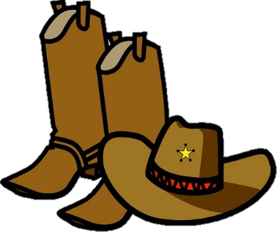  - railroad – a system of trains, tracks, stations, and  other property run by a  transportation company  - trails – paths across  fields or through  the woods
Math  Topic 12: Measuring Length  Topic 15: Graphs and Data  On Friday, we will take a weekly assessment. |  |  | Social Studies/Science  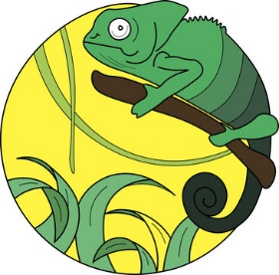  We will study  plants and  animals more  this week.
Spelling Words: No bonus words this week.
1. kindness  2. careless  3. goodness | 4. useless  5. fearless  6. darkness |  |  | 7. sadness  8. sickness  9. helpless | 10. thankless  11. fitness  12. weakness

