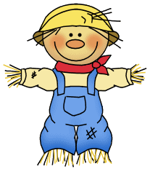October

October 23-27, 2023

**Weekly focus:**

**Theme**– crops/ pumpkins

**Letters**- Vv, Ww

**Sight words**- he, be

**Math**- count to 50 by ones, write recognize and work with numbers 0-10, addition to 5, name 2d and 3d shapes, sort objects, positional words

**Reading/ language-** ask and answer questions about what is read, identify characters in a story, identify parts of a book, produce rhyming words, beginning sounds, identify letters and sounds of the alphabet

**Writing**- names correctly, letters of the week and previously learned letters

(Tt, Bb, Ff, Nn, Mm, Ii, Uu, Cc, Oo, Aa, Gg, Pp, Jj, Dd, Ss, Ee, Rr, Ll, Hh, Kk)

**Important dates:**

* October 23rd- book fair day
* October 24th- farm day
* October 24th- book fair parent night 4:30-7:00
* October 25th-27th- Chick-fil-a PRE ORDER
* October 27th- movie night “Coco” @ 6:30
* October 31st- bring $1 to wear a costume
* November 1st- Cedar Farm field trip
* November 10th-Veterans Day program

**\*ice cream and Chick-Fil-A must be PAID FOR and PRE ORDERED**

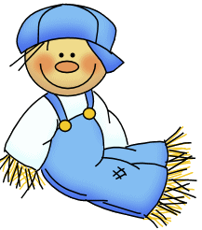

**Reminders:**

*Million cans recycling contest- send in your aluminum cans

*ice cream order forms and money are due Thursday- kiddos will get ice cream on Friday for snack if they purchased

*practice sight words and letters/ letter sounds, and writing letters at home

**FYI:**

* Book fair money must be put on e-wallet.
* Make sure to label your child’s jacket with their name.
* Practice taking jackets on and off independently at home.

