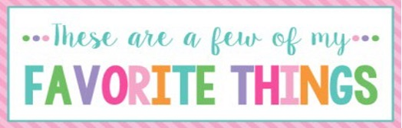
Name: | M ichael E. Baird | T-Shirt Size: | XL
Birthday: | July 30 | Monogram: | MBE
Favorite Color: | Red | Favorite Flower: | Hibiscus
Favorite Scent: | Coconut | Favorite Candy: Sour Gummies | Sour Gummies
Favorite Drink: | Green Tea | Favorite Food: | All things STEAK
Favorite Snack: | Anything NUTS | Favorite Fruit: | Mango
Favorite Restaurant: | Olive Garden | Favorite Fast Food: | Sonic’s Everyday Deals
Favorite Places to Shop: |  | Knowledge Tree, Walmart, Khols
Favorite Bath & Body Works Scent: |  | Anything coconut
Things I Collect: |  | Fancy Pens
Favorite Author/Book Series for Personal Reading: |  | John Grisham’s Novels
Wish List for Classroom: Snacks, Candy, |  | Snacks, Candy, Cute Comfy Chairs/Stool

