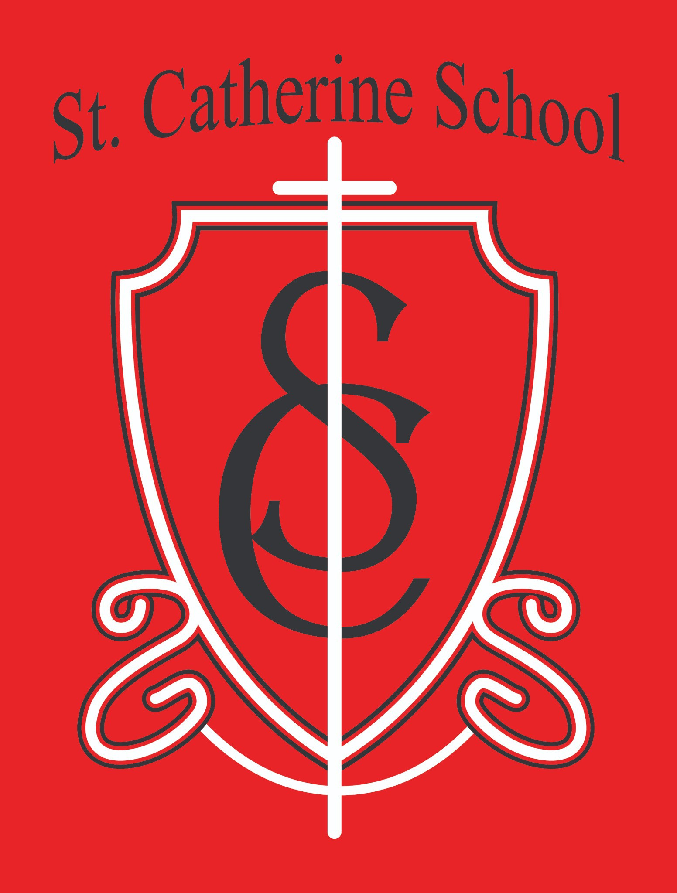

**St. Catherine School Weekly Newsletter** [**https://www.stcatherine.k12.nd.us/parents**](https://nam02.safelinks.protection.outlook.com/?url=https%3A%2F%2Fwww.stcatherine.k12.nd.us%2Fparents&amp;data=05%7C02%7CTerra.Giesen%40k12.nd.us%7C29606ec276d7433570e508dd68acc8cc%7Cdbbf782acef14af186c81f9201061db6%7C0%7C0%7C638781813544036605%7CUnknown%7CTWFpbGZsb3d8eyJFbXB0eU1hcGkiOnRydWUsIlYiOiIwLjAuMDAwMCIsIlAiOiJXaW4zMiIsIkFOIjoiTWFpbCIsIldUIjoyfQ%3D%3D%7C0%7C%7C%7C&amp;sdata=T89wUucvZE%2B8AuC2S3coDn8LFmiSzafPtrigccuJQwY%3D&amp;reserved=0)

# Principal's Message

Dear St. Catherine Families,

This evening, our **Catholic third graders will receive the Sacraments of Confirmation and First Holy Eucharist**—a truly special moment in their faith journey within the Catholic Church. This is a **culmination of their preparation, prayers, and devotion**, marking an important step in their spiritual growth.

I want to extend a heartfelt **thank you to the catechists** who have guided them through this journey, especially **Mrs. Gulmon** for preparing our school students. Your dedication to sharing the faith with our young learners is deeply appreciated.

To our **Catholic third graders**—**may this day be one of joy, grace, and a deeper connection with Christ.** Congratulations on this milestone in your faith!

And for our **non-Catholic students**, we hope that you **continue to grow in joy, grace, and a deeper connection with Christ** alongside your parents. Please know of my prayers for all of our students, our staff, and our families.

# Reminders

* **Reading in the Dark – Friday, March 28th** 📖✨

In celebration of **National Reading Month**, students are invited to **bring a pillow and blanket** to enjoy **Reading in the Dark** next Friday!

* **Daycare Updates** 🏫

**Seeking a daycare director!** The **job description and application** can be found here: [**St. Catherine Employment**](https://nam02.safelinks.protection.outlook.com/?url=https%3A%2F%2Fwww.stcatherine.k12.nd.us%2Femployment&amp;data=05%7C02%7CTerra.Giesen%40k12.nd.us%7C29606ec276d7433570e508dd68acc8cc%7Cdbbf782acef14af186c81f9201061db6%7C0%7C0%7C638781813544055517%7CUnknown%7CTWFpbGZsb3d8eyJFbXB0eU1hcGkiOnRydWUsIlYiOiIwLjAuMDAwMCIsIlAiOiJXaW4zMiIsIkFOIjoiTWFpbCIsIldUIjoyfQ%3D%3D%7C0%7C%7C%7C&amp;sdata=LpcXg8a4MawT2ugERt9PxIgvyydSm88MjhdL1N6wv5I%3D&amp;reserved=0).

Our daycare transformation is well underway! The space is receiving: New ceiling, updated lighting, fresh paint, brand-new flooring Updated bathrooms and kitchen areas

**New washer and dryer** to help maintain a fresh and clean space for our Little Saints!

St. Catherine Little Saints Childcare will be a faith-based center serving our school, parish, and Valley City community, honoring the whole child—socially, emotionally, spiritually, academically, and physically.

* **Early Dismissal – April 2nd** ⏰

School will dismiss at 12:15 PM.

Lunch will be served, and buses will run as usual.

* **Holy Week (No School)– April 17-21**

No school in observance of Holy Week.

* **Tuition Assistance – TAP Application Reminder** 💰

Tuition assistance applications for the **2025-2026** school year are now open. Applications must be submitted through **FACTS Grant & Aid**.

**Deadline: May 15, 2025** (Early applications encouraged for faster award decisions).

📅

Apply here: [FACTS Sign-In](https://nam02.safelinks.protection.outlook.com/?url=https%3A%2F%2Fonline.factsmgt.com%2Fsignin%2F414FV&amp;data=05%7C02%7CTerra.Giesen%40k12.nd.us%7C29606ec276d7433570e508dd68acc8cc%7Cdbbf782acef14af186c81f9201061db6%7C0%7C0%7C638781813544070352%7CUnknown%7CTWFpbGZsb3d8eyJFbXB0eU1hcGkiOnRydWUsIlYiOiIwLjAuMDAwMCIsIlAiOiJXaW4zMiIsIkFOIjoiTWFpbCIsIldUIjoyfQ%3D%3D%7C0%7C%7C%7C&amp;sdata=RNV8ZSYAwWPy6K8FrpKWSXwBieBTFrGVNmskRv%2F4X6I%3D&amp;reserved=0)

If you have any questions, please **contact the school office for assistance.**

* **Virtue of the Week – Fortitude: Perseverance (March 17–28)** 💪

**Focus:** Completing tasks despite difficulties.

**Saint:** St. Monica

**Scripture:** *"Daughter, your faith has saved you."* (Mark 5:25–34) **Application:** Encouraging students to **push through challenges** and track progress on **long-term goals**.

**St. Catherine Spotlight**

**A Huge Thank You to Our Daycare Volunteers & Contractors!** 🏗🔨

A **BIG thank you** to the many **volunteers** who are putting in **countless hours**

to transform our daycare spaces into beautiful, functional environments. We are also incredibly grateful to our **contractors** who are **prioritizing our facility needs** and working hard to ensure we **stay on timeline and within budget**. Your support is making this project possible!



Thank you for your continued **trust, partnership, and support** in our school community. If you have any questions, please feel free to reach out.

Stay Connected with St. Catherine School

📍 **Address:** 540 3rd Ave. NE, Valley City, ND 58072

**Email:** [nicholas.lee1@k12.nd.us](mailto:nicholas.lee1@k12.nd.us)

📧

**Phone:** 1-701-845-1453

📞

**Website:** [www.stcatherine.k12.nd.us](https://nam02.safelinks.protection.outlook.com/?url=https%3A%2F%2Fwww.stcatherine.k12.nd.us%2F&amp;data=05%7C02%7CTerra.Giesen%40k12.nd.us%7C29606ec276d7433570e508dd68acc8cc%7Cdbbf782acef14af186c81f9201061db6%7C0%7C0%7C638781813544087346%7CUnknown%7CTWFpbGZsb3d8eyJFbXB0eU1hcGkiOnRydWUsIlYiOiIwLjAuMDAwMCIsIlAiOiJXaW4zMiIsIkFOIjoiTWFpbCIsIldUIjoyfQ%3D%3D%7C0%7C%7C%7C&amp;sdata=zU%2FG027ciImFWvnpFswmCFRKIDVLpBkCAo3U%2BO1uiQ4%3D&amp;reserved=0)

🌐

📘 **Follow Us on Facebook:** [St. Catherine School on Facebook](https://nam02.safelinks.protection.outlook.com/?url=https%3A%2F%2Fwww.facebook.com%2Fst.catherineschoolvc%2F&amp;data=05%7C02%7CTerra.Giesen%40k12.nd.us%7C29606ec276d7433570e508dd68acc8cc%7Cdbbf782acef14af186c81f9201061db6%7C0%7C0%7C638781813544102089%7CUnknown%7CTWFpbGZsb3d8eyJFbXB0eU1hcGkiOnRydWUsIlYiOiIwLjAuMDAwMCIsIlAiOiJXaW4zMiIsIkFOIjoiTWFpbCIsIldUIjoyfQ%3D%3D%7C0%7C%7C%7C&amp;sdata=6LDWhRU9LS7c%2BbQsBfTBW9Ij5FxVMNrXAqoxs%2FzBZOI%3D&amp;reserved=0)

*“Inspiring excellence through faith, learning, and service.”*