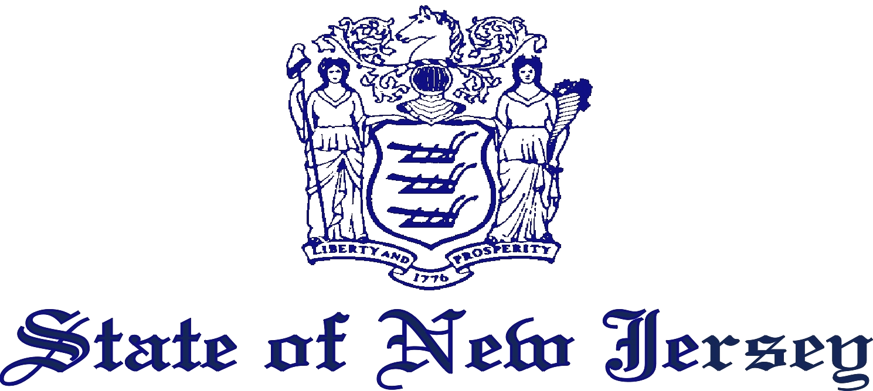

DEPARTMENT OF HEALTH AND SENIOR SERVICES
PO BOX 360
TRENTON, N.J. 08625-0360
www.nj.gov/health
Jon S. Corzine
Governor
Fred M. Jacobs, M.D., J.D.
Commissioner

April 15, 2006

NOTICE
On April 15, 2006, the “New Jersey Smoke-Free Air Act” (Act), N.J.S.A. 26:3D-55 et seq., took effect. The Act prohibits smoking in an indoor public place or workplace. The Act also prohibits smoking in any building or on the grounds of a public or nonpublic elementary or secondary school, regardless of whether the area is indoors or outdoors.
The Act and the Smoke-Free Air Rules of the Department of Health and Senior Services at N.J.A.C. 8:6 implementing the Act require this establishment to direct a person smoking in violation of the Act to stop smoking. The rules further require this establishment to remove from the premises any person who continues to smoke in violation of the Act after having been directed to stop smoking, and to enlist the assistance of local law enforcement or peace officers, if necessary, to assist in the removal.
Persons who violate the Act are subject to a complaint being filed against them and being summoned to appear in the municipal court of this jurisdiction. Persons found to be in violation of the Act are subject to fines and penalties established by the Act of $250 for a first offense, $500 for a second offense, and $1,000 for each subsequent offense.
Fred M. Jacobs, M.D., J.D., Commissioner
New Jersey Department of Health and Senior Services

