FRANKLIN COUNTY HIGH SCHOOL
EXAMPLE BASIC COLLEGE FOUR-YEAR PLAN
CLASS of 2026 or Later

NAME: _____________________________________________________ DATE: ________________________________
Tennessee Graduation Requirements:

English: 4 credits
Math: 4 credits
Science: 3 credits
Social Studies: 3 credits
Personal Finance: 0.5 credit
Wellness: 1 credit
PE: 0.5 credit
Fine Arts: 1 credit
Foreign Language: 2 credits
Elective Focus: 3 credits
Additional Requirements:
In addition to the above requirements, Franklin County requires 6 additional credits for a total of 28 credits needed in order to graduate. Students are required to take the ACT. Each student’s course of study in high school is based on individual interests and needs. In addition to in-person AP math and science classes, FCHS now offers online AP classes at no cost for juniors and seniors with at least a 3.0 GPA. Classes offered are listed on the back of this sheet. Students on this path may take Career & Technical Education courses, honors courses, dual credit courses, and/or AP courses if he/she meets prerequisites. AP classes are 5 weighted points towards the GPA. Honors, Dual Credit, and Dual Enrollment classes are 4.5 weighted points towards the GPA. Please visit our website at https://fchs.fcstn.net/ and click on “Guidance” for information.
FCHS REQUIRES 28 CREDITS FOR GRADUATION
9th Grade 10th Grade
1. English I 1. English II
2. Algebra 2. Geometry
3. Physical Science 3. Biology I
4. World History 4. Tennessee History
5. Wellness 5. Fine Arts
6. Career Exploration/PE 6. Elective (Focus)
7. Elective (Focus) 7. Elective
8. Elective 8. Elective

11th Grade 12th Grade
1. English III 1. English IV
2. Algebra II 2. Pre-Calculus, Statistics, or SAILS math
3. Chemistry 3. US Gov’t & Civics/Contemporary Issues or TBD
4. U. S. History and Geography 4. Personal Finance/Economics
5. Foreign Language I 5. Elective or Work Based Learning or Foreign Language III
6. Foreign Language II 6. Elective or Work Based Learning
7. Elective (Focus) 7. Elective or Work Based Learning
8. Elective 8. Elective or Work Based Learning

POST SECONDARY PLANS
2 Year College: _____ 4 Year College: _____ Tech School: _____ Military: _____ Job: _____
*************************************************************************************
The above is a general plan based upon state guidelines. Plans may change from year to year.
Student Signature__________________________________________________________________________

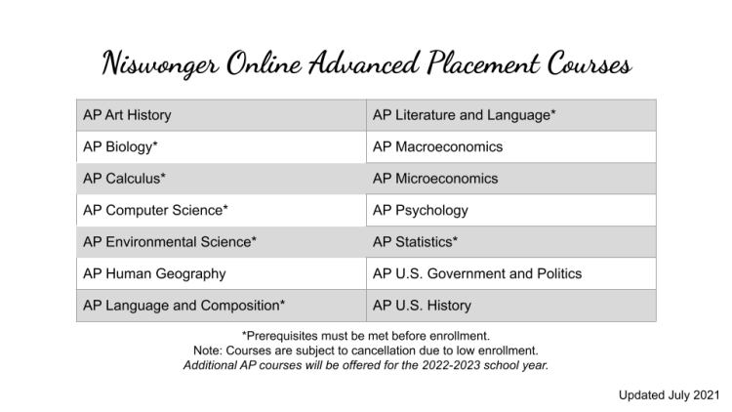
Prerequisites:
AP Art History: No prerequisite - Great introductory AP course!
AP Biology: In person Niswonger prerequisites are Biology I and Chemistry I. Algebra I is
recommended. FCHS prerequisite is honors Biology.
AP Calculus AB: In person Niswonger prerequisites are Algebra I, Geometry, Algebra II, Pre-Calculus or Trigonometry/Analytical Geometry. FCHS prerequisite is honors Calculus.
AP Calculus BC: Prerequisites are Algebra I, Geometry, Algebra II, Pre-Calculus or Trigonometry
AP Computer Science A: Prerequisite is Algebra I. Algebra II is recommended.
AP Environmental Science: Prerequisite is Algebra I. Two years of high school science with labs is recommended.
AP Human Geography: No prerequisite - Great introductory AP course!
AP Language & Composition: Prerequisites are English I and English II.
AP Macroeconomics: No prerequisites. Algebra I is recommended.
AP Microeconomics: No prerequisites. Algebra I is recommended.
AP Psychology: No prerequisite - Great introductory AP course!
AP Statistics: Prerequisite is Algebra II.
AP US Government & Politics: No prerequisite
AP US History: No prerequisite
AP Literature & Composition: Prerequisites are English I, English II, and English III or AP Language & Composition.

