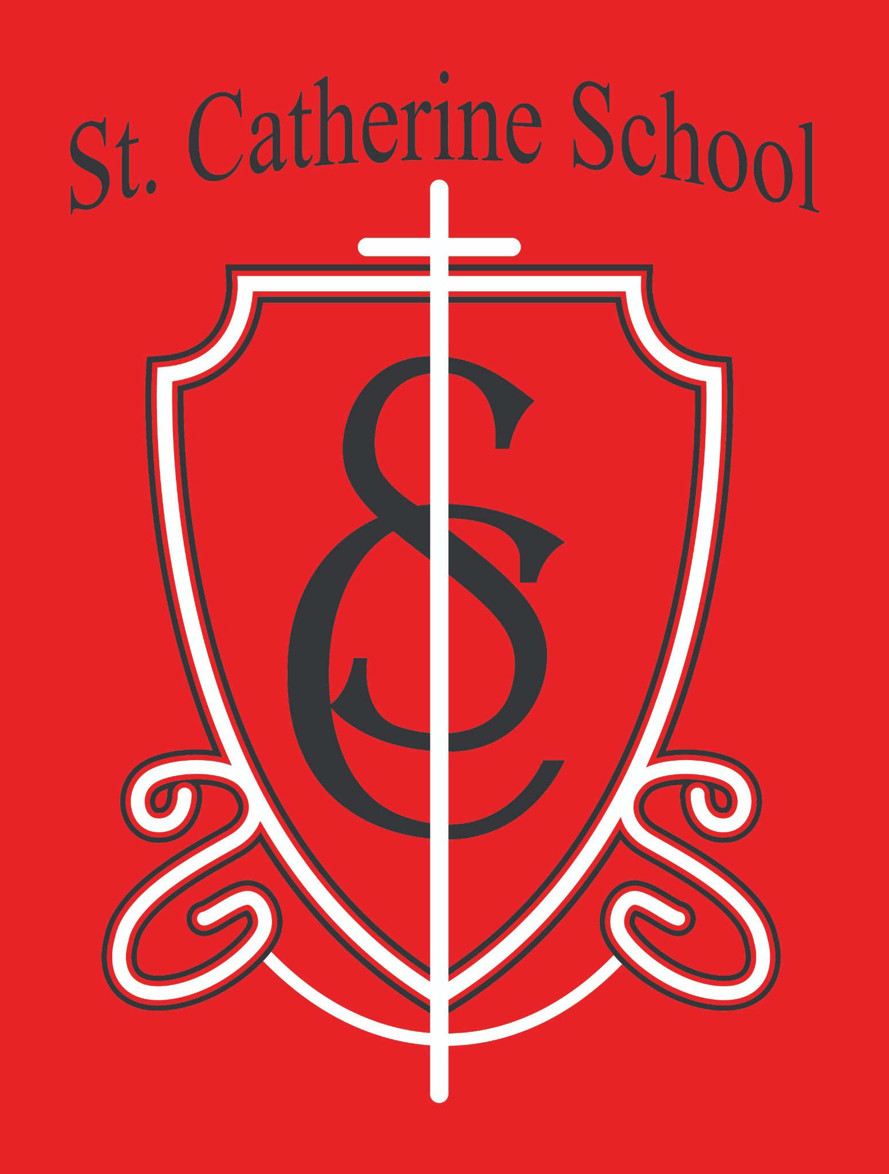

St. Catherine School Weekly Newsletter (Week of September 7-11)
https://www.stcatherine.k12.nd.us/parents

Principal's Message
Dear St. Catherine Families,
Thank you for helping us start the school year off on a wonderful note! From our students’ enthusiasm for learning to the support you provide each morning, there is much to be grateful for in our school community. Please take a moment to review the reminders and upcoming events below. A lot is happening in the next couple of weeks!

Reminders

Picture Day – Tuesday, September 15
Scherling Photography will be here next Tuesday morning, September 15, for school pictures. When scheduling appointments, please make every effort to have your child at school that morning. We understand that illnesses and emergencies happen, but arranging a makeup session may be challenging. Thank you for helping us include every student!

All-School Mass – Thursday, September 17
Please RSVP to Ms. Giesen in the school office for next week’s All-School Mass on Thursday, September 17. You can call 701-845-1453 or email terra.giesen@k12.nd.us.

VCHS Homecoming Parade – Friday, September 25 at 4:00PM

St. Catherine School will have a float in this year’s Homecoming parade! For our new families, riding on the St. Kate’s float is a popular school tradition—in past years, a majority of our students have participated. We know some students may choose to join other community groups or sports teams, and we welcome all who would like to ride with St. Catherine!
We need your help with: A trailer
Volunteers to ride or walk with the float Decorators
Candy donations!
We kindly ask each family to consider donating one bag of candy—and more is always welcome! With 30-plus kids tossing candy along the parade route, we go through a lot!
A permission slip will go home Monday with more details. Here is what families can expect on Friday, September 25:
Students who are not riding the float will be dismissed as usual.
Students who are riding the float will stay at school after dismissal. We will provide a snack and get students to the parade route before the 4:00 PM start.
After the parade, the truck and trailer will return to St. Catherine School for student pickup at approximately 4:30 PM, depending on when the parade ends.
I will share more Homecoming information as I receive details from VCPS, including plans for the pep rally.

Fall Parent-Teacher Conferences and Book Fair
Please mark your calendars for fall parent-teacher conferences on Thursday, October 8. Our Book Fair will run October 5–9, during conference week. We'll share more details as we get closer.

Fall Auction – Friday, November 6
Save the date for our Fall Auction on Friday, November 6! This year’s theme, Anchored in Faith, celebrates the shared faith and identity that bind our St. Catherine community together.
It’s a great night to book a babysitter, enjoy an evening together, and bid high to support our school's mission! Fall Auction Chair Alison Kasowski and the school office will share more information in the coming weeks. We are so thankful for your support of this annual event.

Little Saints Updates
Little Saints Childcare Center currently has two openings in our preschool room for children ages 3–5, along with multiple openings in our school-age program for before- and after- school care.

We offer special preschool-room rates for Circle of Friends (COF) families. If you are currently paying for childcare and transportation to and from COF, this may be a great time to consider making the switch to Little Saints!
For enrollment information, visit our Little Saints webpage.
We’re also hiring! We are looking to fill a few part-time float teacher positions and a full- time infant lead position. Please share these opportunities with anyone who might be interested in joining our team.
For employment information, visit the Employment tab on our website or contact Beth Nadelin, Childcare Director, at 701-490-3800 or beth.nadelin@k12.nd.us.

St. Catherine Spotlight
Sixth Grade Eco Ed Adventure
Our sixth graders attended the Barnes County Eco Ed Camp at Wesley Acres this week, where they learned a lot and were wonderful representatives of St. Catherine School! Yesterday, it was a joy to hear their excitement as they shared what they learned and the experiences that stood out. We are proud of their curiosity, enthusiasm, and the way they represented our school!
A Great Start to the School Day
We have enjoyed wonderful attendance and timely arrivals for breakfast and morning drop-off as we begin the school year! Thank you, parents, for helping your children arrive ready to learn. Your support helps us start each day together on a positive note!
Thank you for your continued partnership and for all the ways you support St. Catherine School. May God bless your family with a restful and joyful weekend!



Stay Connected with St. Catherine School
📍 Address: 540 3rd Ave. NE, Valley City, ND 58072
Email: nicholas.lee1@k12.nd.us
📧
Phone: 1-701-845-1453
📞
Website: www.stcatherine.k12.nd.us
🌐
📘 Follow Us on Facebook: St. Catherine School on Facebook

“Inspiring excellence through faith, learning, and service.”

