KEEP MACHINING IN AMERICA
THE DONALD & BARBARA EIFERT/
DON’S MACHINE SHOP SCHOLARSHIP

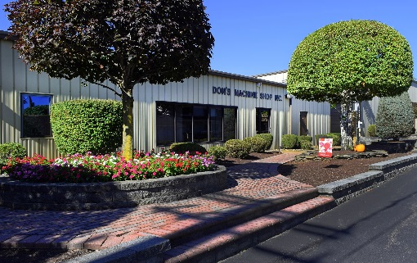

INTERESTED IN THE TRADES????

A wonderful opportunity is available here in the Wyoming Area School District for any graduating senior (male or female) who has a sincere interest in learning a specific trade with hands on experience and a job offer at the end of the training. (see criteria)

Don Eifert, Sr. began this highly successful business in 1981 in a garage located behind his father and mother-in-law’s home. The business expanded slowly over the years as a result of Don putting in long hours and sometimes working 7 days a week. His reputation grew because of the quality work he put out and his fairness to his customers. Decades later this first class operation now sits across the street from his home in West Pittston.

Don’s Machine Shop now does work for a wide variety of manufacturing businesses around the world. Some of the industries served are paper, wire rope, pharmaceutical, food and beverage, plastic, glass, printing, agricultural, mining, architectural, audio equipment, aerospace, railroad, and other sub industries of these. Over the years Don’s has expanded the facility, purchased new machinery to meet the needs of their customers, and continually updates this machinery to keep up with the newest advances in technology. They now have a clean, modern, climate controlled facility located at 777 Ash Street in West Pittston, PA that can meet the needs of manufacturing businesses around the world.

Currently the business is run by Don Jr., and employs his two sisters: Michelle and Christina, his wife Erica, and his three children, Donnie, Dakota and David.

Over the past decade there has been a continuing decline in the number of high school graduates choosing to enter the trades. This is due to many students feeling the need to go to college because they don’t understand the opportunities that are available in the trades. Many young people picture the old machine shops being dirty, not well lighted and they don’t know that it isn’t like that anymore. The Don’s Machine Shop facility is clean, well-lighted, heated and fully air conditioned. Employees receive good pay, health, dental, and eyeglass benefits paid in full, 401K, employee life insurance, and paid holidays.

The lack of students entering the trades has created a real problem. Employees in the trades are getting older and retiring and all of the knowledge they have gained over the years from experience is not being passed on to anyone. The trade is losing a generation of knowledge.

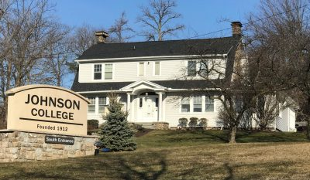
In order to try to attract more capable high school seniors and graduates, Don Jr. reached out to Johnson College, a local highly successful tech school with an excellent reputation for training
young people in the tech opportunities available to them. Don Jr. contacted Mike Novak, Chief Administrative Officer, and asked him if he would be interested is starting a school at Don’s Machine Shop. Mike toured the facility and Don Jr. toured Johnson College and both agreed it would be a good fit. Don Jr. set up a full machine shop to be used for the classes. There are manual milling machines, manual lathes, CNC milling machines and a CNC lathe as well as 12 computer work stations to learn to use CAD/CAM software.

The first class started in November 2019. There were 10 students who received Certificates of Completion for the Computer Numerical Controls (CNC) class. The second class in June 2020 and 7 students and the last class held in March 2021 had only 4 students. Of the 21 students that have gone through the program 4 currently work at Don’s Machine Shop. They are earning a good wage, continuing to learn the trade from other employees, have full benefits, and have no burden of a large student loan.

REQUIREMENTS: Must have an active application on file with Johnson College for Computer Numerical Control (CNC) 510 hour class. Application can be found at https://johnson.edu/continuingeducation/. Click on 510 Computer Numerical Control (CNC) at Don’s Machine Shop.
Financial need may be considered. But most important is the sincere desire to enroll in this program. This scholarship will be paid directly to Johnson College by the Eifert family. Value is $7,500.00

CRITERIA: Applicants will be interviewed by an Eifert Selection Committee headed by Don Eifert, Jr, Erica Eifert and anyone else they select from the business. Applicants are encouraged to bring their parents to the interview with them. The Eifert Selection Committee will make the final selection for third award.

