2026-27 Kindergarten Supply List
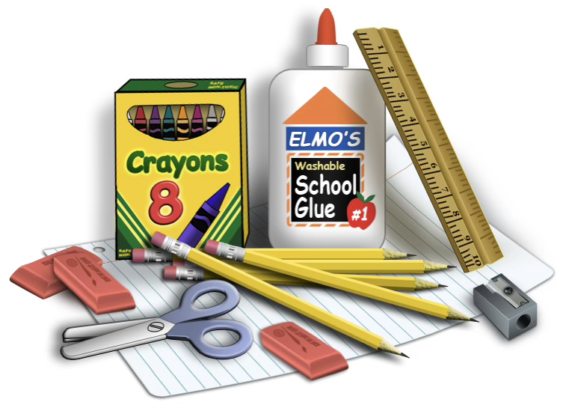
Please provide the following if possible:
- 1 pair of head phones (not ear buds or blue tooth)
- Pencil BOX – regular size (box, not bag)
- 2 boxes #2 pencils. (These are the only pencils that seem to work well in our pencil sharpeners)
- 4 Boxes of 24 Crayola crayons
- 1 box of colored pencils
- Skinny, black Expo markers (we use a LOT of these)
- 2 composition notebooks that are labeled primary. They have a place to draw pictures.
Donated Items welcome!
- Markers (skinny and fat)
- Tissues
- Pink Erasers
- Glue Sticks
- Small liquid glue
- Child scissors
- Paper towels. (we go through a lot of these because we make messes and are learning to clean them up)
- Ziploc baggies – gallon, quart and snack size are needed.
- Colored and white card stock
- Clorox Wipes
- Hand Sanitizer
- Baby wipes – (we go through LOTS of these because of snack, cooling down, cleaning hands, cleaning tables, etc.)
Please put your child’s name on the outside of backpack, lunch box and pencil box! (we do not need their name on any of their supplies)
Arizona law requires that public schools provide the supplies required for academic success. All materials required for a student’s education will be provided by the Nadaburg Unified School District. This supply list represents general, optional items that you may supply at your discretion. If you have questions regarding the optional supply list, please contact your child’s school.

