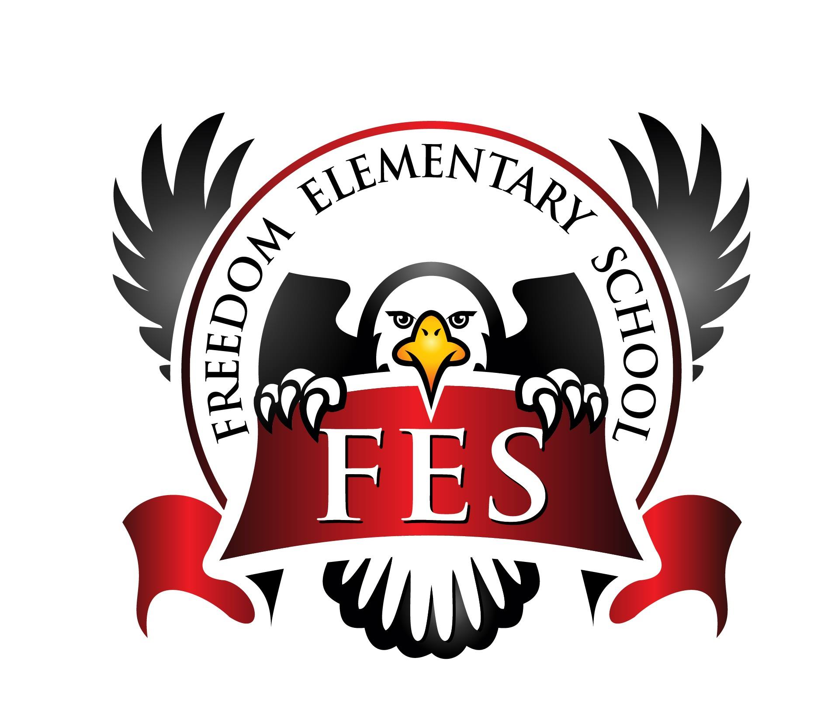

Freedom Elementary
23-24 SY

Opportunities available for families to be involved in their child’s education:

School Volunteers (reading with kids, party planning, helping in the classroom, field trip, mentors, guest speakers, etc.)
Contact : Leslie Lancaster, Principal - (270)887-7150

Feedback on surveys and Title I documents (parent involvement policy, school compact revisions, Title I events, etc.)
Contact: Kim Lint - (270) 887-7150 (ext.72957)

Attend parent conferences:
Contact: Classroom Teacher - (270) 887-7150 (ext)

Attend Open House/ Title I Annual Meeting
Contac: Freedom Elementary/Kim Lint - (270) 887-7150 (ext.72957)

Parent Portal (access student schedules, grades, attendance records, assignments due, etc.)
https://www.christian.kyschools.us/
Contact: Sara Ogelsby-(270) 887-7150 (ext.72958)

School Newsletter (stay informed with current school news)
Contact: https://freedom.christian.kyschools.us/home or Classroom Teacher (270) 887-7150
https://www.facebook.com/search/top/?q=freedom%20elementary

Additional Support Systems available (Guidance Counselors, family resource center coordinators)
Contact: Amanda Baxter or Raiona Henderson, Guidance Counselors - (270) 887-7150 (ext. 72960/72961)
Family Resource Center - Chris Dudley - (270)887-7150 (ext. 72970/72971)

Parent communication folders - sent home daily/weekly
Contact: Classroom Teachers - (270) 887-7150 (ext)

Parent Workshops:
Contact: Derrick Tuck, Community Liaison - (270)887-7150 (ext.72804)

Check Title I Activity Calendar on schools website/ title I tab or FaceBook
Contact: https://freedom.christian.kyschools.us/home
https://www.facebook.com/search/top/?q=freedom%20elementary

