Voorhees Wrestling Camp 2022
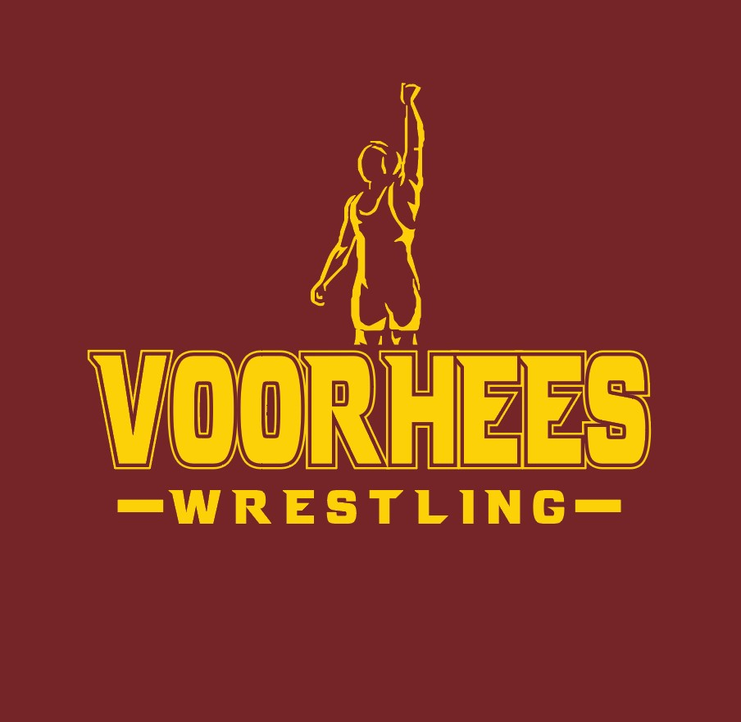
Dates: July 18-July 21
Time: 8:30AM-12:00 PM
Cost $130
All interested wrestlers are welcome
This camp is designed to be a fun, structured and beneficial summer wrestling camp hosted at Voorhees High School for elementary, middle school and Freshman athletes grades Pre K-9. Our camp is hosted by Coach Kurtz and Two-Time State Champion Jacob Cardenas. Cardenas currently wrestles for Cornell University. Jacob will be teaching the older and more experienced wrestlers and Coach Kurtz will be teaching the Novice wrestlers. Don’t miss this great opportunity!!
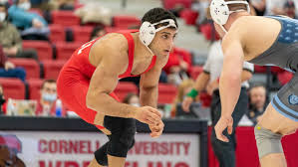

How to Sign Up
https://orgsites.sportsoffice.com/sport.php?level_id=1&org_id=82&sport_id=359

Contacts
Coach Ricky Kurtz (908) 797-2796
Assistant Athletic Director Marc Cahill (908) 638-2107

