HOLLY SPRINGS SCHOOL DISTRICT
5th GRADE SCIENCE HYBRID INSTRUCTIONAL GUIDE
Week of September 7-10th, 2021

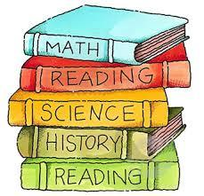

STANDARDS
P.5.5B.1 Obtain and evaluate scientific information to describe what happens to the properties of substances in mixtures and solutions.
P.5.5B.2 Analyze and interpret data to communicate that the concentration of a solution is determined by the relative amount of solute versus solvent in various mixtures.

STANDARD (S)  P.5.5B.1 Obtain and evaluate scientific information to describe what happens to the properties of substances in mixtures and solutions.  P.5.5B.2Analyze and interpret data to communicate that the concentration of a solution is determined by the relative amount of solute versus solvent in various mixtures.  ESSENTIAL CONCEPTS  Can the student explain what a mixture is?  STANDARD VOCABULARY  - Mixture: a substance where different materials are put together but keep its own properties.  - Solution: is a mixture in which substances are spread out evenly and do not settle to the bottom of the container.  - Components: a part of something.  - Solubility: is a property of material that refers to how well it dissolves in another material.  - Soluble: any solution or substance that dissolves in another liquid.  - Insoluble: any solution or substance that does not dissolve in another liquid.  - Solute: a substance that dissolves in a solution.  - Solvent: the substance in which the solute is being dissolved. | ACTIVITY/ ASSIGNMENT SCHEDULE  Monday – Holiday, NO SCHOOL  NO SCHOOL, HOLIDAY  Tuesday – SAVVAS Science Books, I DO, and Exit ticket, Sept. 7th.  - Read aloud from Science Books on pages 78-81.  - Complete I Do, We Do, and You Do  - Exit ticket  Wednesday – Independent Instruction, Additional Support, Sept. 8th.  - Students complete their Quick Quiz.  - Students will be Pulled for additional support.  - Independent Practice for students who are not pulled to complete GROUP WORK: USA TEST PREP Vocabulary Worksheet and Enrichment: Mixtures & Solution Worksheet.  - Homework USA TEST PREP Mixtures Worksheet.  Thursday – Teacher Assisted Instruction, Independent Practice, and Pulling, Sept 9th.  - Students will be Pulled for additional support.  - Independent Practice on page 82 in SAVVAS Science books for students who are not pulled to complete as well as present their work.  Friday – Bi-Weekly Assessment, Pulling and Independent Practice, Sept. 10th.  - Bi-Weekly Assessment (Test) in Performance Matters in all subjects.  - Pulling for students who were absent during pulling on Wednesday, or who need additional help in science.  - Independent practice worksheet on page 84 in SAVVAS Science book.
P.5.5B.1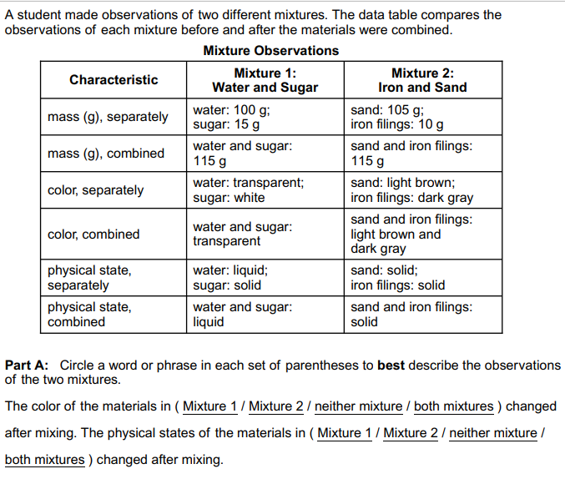  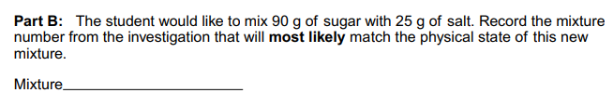  P.5.5B.2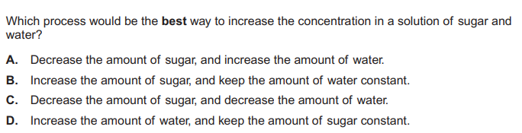 | WEBSITES/SUPPORT MATERIALS  District website – hssdk12.org  School website - intermediate.hssdk12.org  Schoology-schoology.com  Savvas Realize- savvasrealize.com  Performance Matters-performancematters.com  USA TEST PREP-usatestprep.com

