DR Mission Partners
FY 2022-2023
(July 1, 2022- June 30, 2023)

Quarter 1: Operation Christmas Child
https://www.samaritanspurse.org/what-we-do/operation-christmas-child/
August 28th – October 30th
Quarter 2: Journeys Lutheran School
https://www.journeyslutheran.org/
November 6th – January 15th
Quarter 3: South Wisconsin District Mission Support
https://swd.lcms.org/mission/partners.html
January 22nd – March 19th
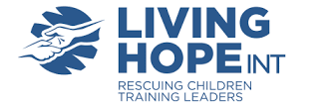
Quarter 4: Living Hope International
https://lovehopemercy.org/
March 26th – June 4th
Quarter 5 (Summer Quarter): A Place of Refuge
https://www.aplaceofrefuge.org/
June 11th – August 27th

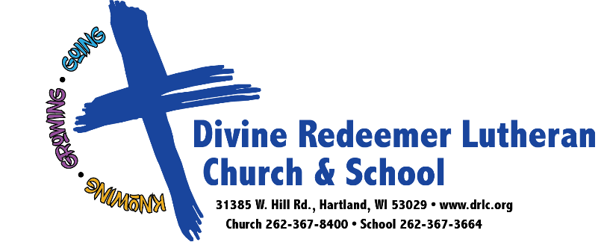

DR Mission Partner Information

Mission Partner Scheduling:
Divine Redeemer operates on a “quarterly” mission partner rotation with 5 core mission partners. These are the mission partners that are supported in our annual budget, through individual special gifts (if applicable), and through our chapel offerings during the school year. The idea is to have our church and our school support the same mission at the same time. This enables us to further our church and school relationship by encouraging partnership between our congregation and school families as we get excited about the same mission together! The mission that is being highlighted in our worship services is also the mission that is being highlighted in our school for that quarter.
Since there is a time where school is not in session (summer) that doesn’t mean that we stop focusing on mission at DR! Our summer mission partner this fiscal year is A Place of Refuge.
The dates listed above are approximate that correlate to Sundays where church mission partnership is highlighted. You will notice that the dates of these Sundays correlate to our school’s quarterly academic calendar when school is in session.
Mission Partner Considerations:
There is no shortage of missions to support to further Christ’s Kingdom! Praise God for working through the church in this world! However, in order to be effective in mission work at Divine Redeemer, we need to be judicious as to which missions we support. If we support too little of an amount of mission partners, we are not stewarding our gifts wisely to fully serve His kingdom. If we support too many mission partners, we will end up stretching our support too thin and will start to lose the connection to our mission partners as we try to support too many missions.
With these considerations in mind, these are some of the considerations that go into place when prayerfully selecting mission partners at Divine Redeemer. This list is not exhaustive but will give you an idea of the thought process that goes behind how mission partners are selected.
- Christ-Centered: We want our mission partners to clearly share the love of Jesus with the people they serve! Each mission partner is reviewed to make sure that their teachings do not conflict with our mission, vision, and values of Divine Redeemer.
- Balance Between Local and Global: We want to balance the support of local mission and global mission so that we can support mission in our community and around the world.
- High Level of Congregational Involvement: We want mission partners who can engage our congregation and school families in a variety of ways (not only supporting these mission partners financially but also allowing for ways for people to use their time and talents as well).
- High level of Communication: We want mission partners who are responsive and committed so we can develop strong partnerships with the missions we support. We want missionaries and representatives who can share the story (in person where applicable) of how Christ is changing lives through their mission work.
May Jesus’s love be made known to all nations as we continue knowing, growing, and going in Christ!
“…You will receive power when the Holy Spirit has come upon you, and you will be my witnesses in Jerusalem and in all Judea and Samaria, and to the end of the earth.” -Acts 1:8

