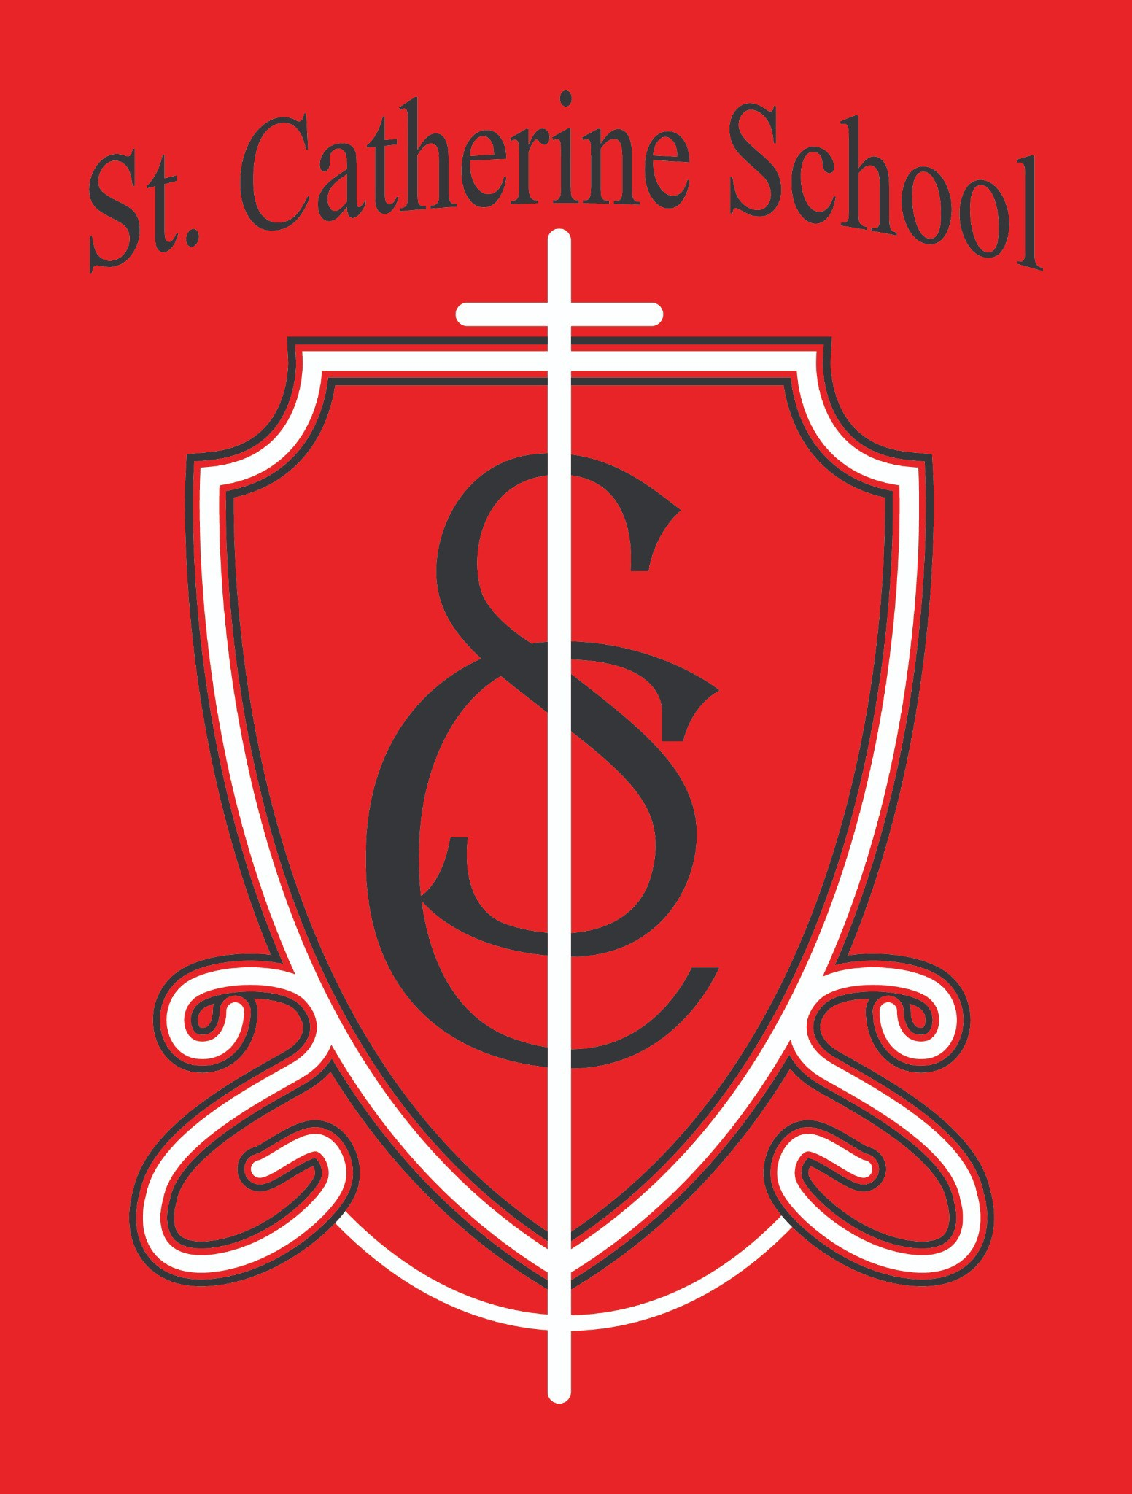

St. Catherine School Weekly Newsletter Week of 10/20/2025-10/25/2025
https://www.stcatherine.k12.nd.us/parents

Principal's Message
Dear St. Catherine Families,

Resending this email — there was an update to mobile rendering for Outlook that wasn't displaying on phones using Outlook or specific email clients. Thank you to those who brought that to my attention. I believe this has been fixed. You won’t be able to view previous weekly emails on your phone either, but copies of my weekly newsletters are posted on the parent tab on the website.
I hope you are doing well! Below are this week’s updates and reminders as we move deeper into October.
Before the start of this week, I asked God to help me figure out what He wanted me to say, and I’ll admit— I was stumped. There’s so much going on and so many directions pulling at once. This week, I helped fill gaps as the school cook, custodian, teacher, and childcare helper. I haven’t had a day where I went home early, but through it all, I’ve been reminded that having faith means understanding that I’m not the “planner.” God is. Wherever I’m needed to serve this school is where I’m meant to be. Whether it’s listening to a Pre-K student’s story, helping a 3-year-old learn expectations, serving breakfast, or cleaning up a mess—it’s all service, and it’s all joy when it’s done for His glory.

Reminders
Fall Festival – Pumpkin Donations Needed: We are still in need of 55 pumpkins for the Fall Festival on Wednesday, October 29th, or donations to help support the purchase of pumpkins for our St. Catherine School students and Little Saints Childcare kids. We would be so appreciative of any support in this area!
Saints Parade – Wednesday, October 29th:
We sent out details earlier this month, but here are a few reminders:

This is a reverse parade, so families are invited to bring treats or small items to hand out to staff and students—about 50 will do!
Parents, please send a Saints costume with your child. Costumes can be simple— think a blue sheet and baby doll for Mary, or a sword and shield for St. Michael the Archangel. There’s no need to go extravagant!
After the parade, we’ll take a picture of all our “Saints in the Making”. Parents who attend may pick up their children early from the school parking lot following the parade.
Those who can’t make it—no worries! Normal dismissal procedures will still apply.

The parade route will come out of the parish office doors, pass in front of the rectory and church on the west side, and make a loop through the church parking lot so everyone can see the Saints’ costumes.
Auction Business Contacts: Please reach out to any businesses still on your list if you haven’t done so yet.
Auction Donations Delivery: If you still have items to donate for the Fall Auction, please contact Ms. Giesen in the office if you need help getting them to the school.
Volunteer Need – Kickoff Breakfast: We are still in need of 4–5 volunteers for each shift at the Kickoff Breakfast next weekend (Sunday, November 2).
Shifts: 8:00–10:30 AM and 10:30 AM–12:30 PM
Please email Fall Auction Kickoff Chair, Janessa Kennedy, at
janessa.kennedy@k12.nd.us if you can help. Thank you for serving in this way!

Support the School: Trimming “Our Family” labels and dropping them off at the church or school office helps support our mission. Every label helps—thank you to the Catholic Daughters for organizing this effort!
Cooler Weather Reminder: Per our handbook, no shorts after October 1. With temps around 50°, please make sure your child comes dressed for fall recess weather.
Little Saints Enrollment Special: Enroll full-time in October and get your first two weeks of care free.

St. Catherine Spotlight
Our 5th and 6th graders took a trip to the St. Catherine Cemetery on Friday, October 24th. They helped clean up, prayed, and took time to reflect. The students were so respectful, and I was proud to witness their example of our mission in action—inspiring excellence through faith, learning, and service.
This week also highlighted our incredible staff. Two staff members stayed late after school to finish decorating the museum window for our upcoming Fall Auction. Service is so deeply engrained in our identity at St. Catherine School that it can feel almost unnecessary to point it out—but in a world that often says “put yourself first,” it’s inspiring to see our staff live out Christ’s call to serve others with joy and humility.

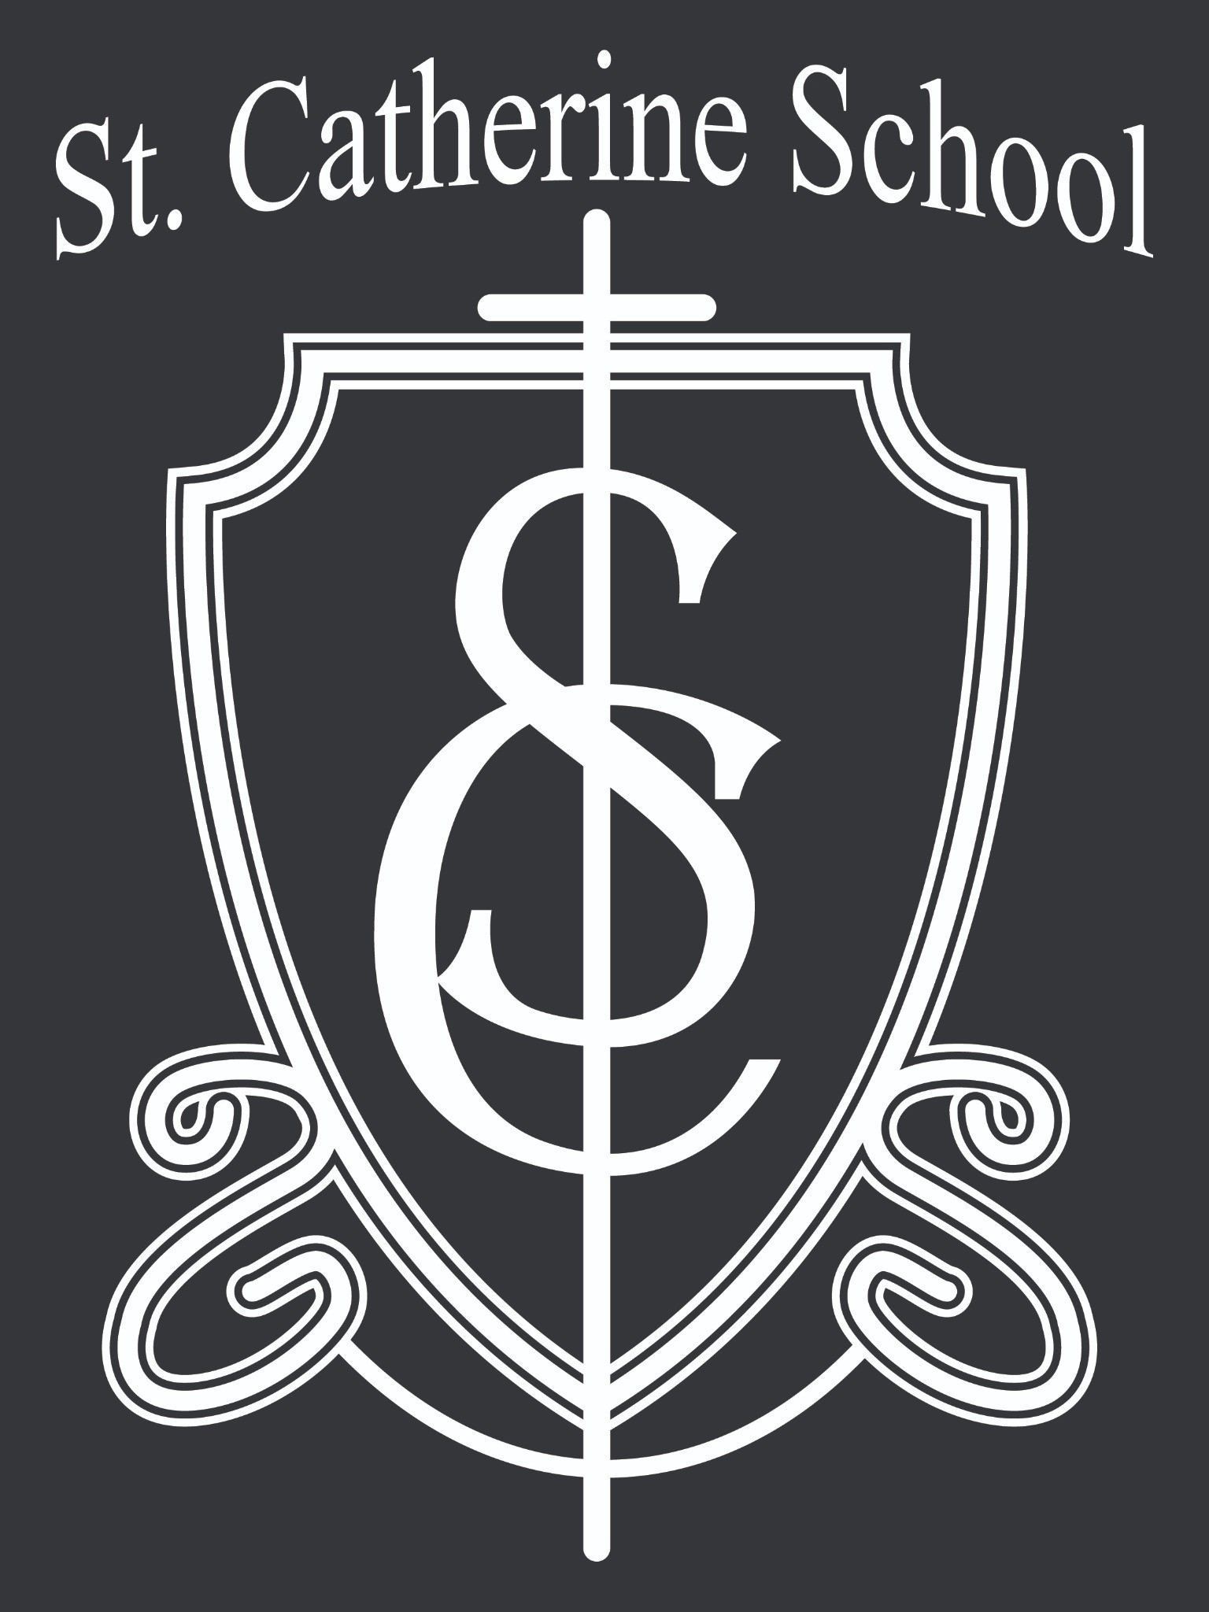
And finally, a big thank you to everyone who has donated or helped gather items for the 53rd Annual Fall Auction. So many great items are rolling in, and it’s a beautiful reflection of the generosity and community spirit that define St. Catherine School. We are so thankful for your continued support!
Thank you for your continued prayers, encouragement, and support for our mission of Inspiring Excellence through Faith, Learning, and Service.
Stay Connected with St. Catherine School
📍 Address: 540 3rd Ave. NE, Valley City, ND 58072
Email: nicholas.lee1@k12.nd.us
📧
📞 Phone: 1-701-845-1453
🌐 Website: www.stcatherine.k12.nd.us
📘 Follow Us on Facebook: St. Catherine School on Facebook

“Inspiring excellence through faith, learning, and service.”

